Lovetropolis.com is actively Seeking Venture Capital and Angel Investors
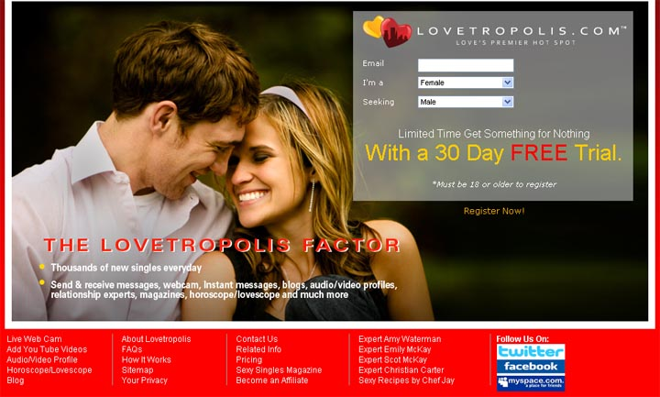

Released on: June 18, 2009, 7:13 am
Author: The Lombard Company, Inc
Industry: Internet & Online
June 17, 2009—The Lombard Company, Inc. owner and CEO Michael Lombard announced today that his company is actively seeking capital investment in his popular new online dating site, Lovetropolis.com, which launched in February, 2009.
The Lombard Company, Inc., parent company of Lovetropolis.com, “will evaluate investment offerings from individual venture capitalists, venture capital firms and angel investors”, Mr. Lombard said. Lovetropolis.com was designed and launched to modernize the online dating industry and to outdistance sites like Match and eHarmony.
"I'm looking for minority investors to join me as Lovetropolis.com overtakes Match and eHarmony and revolutionizes online dating," Lombard said. Confident in his design and features formulation, Lombard stated, “We are gaining market share and growing our database of members every day. And, given current economic conditions, shrewd financiers will understand that Lovetropolis.com offers one of the very few recession-proof investment opportunities in the marketplace. At the end of the day, I'll be able to aggressively market my company and benefit from the insight and advice of new partners who will enjoy lucrative returns on their investments. That’s a win-win in my mind,”
An entrepreneur with extensive executive experience, Mr. Lombard has previously owned and run a successful SME and is adept at directing strategic business development and creating market share for new, innovative products. Under Lombard’s management, Lovetropolis.com has already been listed as one of the top five major online dating services by Online Dating Magazine and was evaluated to be “The Next Great Dating Service” by ALoveLinksPlus, which is touted as one of the choosiest directories in the industry.
This past March, YouNoodle predicted the value of Lovetropolis.com would reach $44.7 million, by summer’s end. At that point, the dating site will only be about six months old. With a five-year business plan in hand, Mr. Lombard is enthusiastic about the investment potential of Lovetropolis.com. “We are poised to be the first dating site in a decade to really have what it takes to compete against the big commercial sites like eHarmony and Match,” he said.
Michael Lombard has made significant investments in Lovetropolis.com, designing it with a vision of creating a state-of-the-art, high quality online dating website. Unlike a typical dating site, Lovetropolis.com provides an entirely unique forum for connection, communication and entertainment. Additionally, the site is forecast as an excellent investment because it has successfully navigated beyond the start-up phase. Lovetropolis.com enjoys a well-established technical and corporate infrastructure supported by leading companies in the industry and a great team of executives and key staff.
Mr. Lombard wants to be sure that potential investors understand that Lovetropolis.com is the answer to an increasing market demand. In addition to finding a mate, singles utilizing online dating services want access to the methods of communication and volumes of entertainment information now available on the Internet, and access at a cost they can afford and in such a way that they aren't socially isolated. Lovetropolis.com provides the singles' community with a social, entertaining atmosphere for worldwide communication and connectivity.
Recently, Lovetropolis.com has entered into collaborative partnerships with four of the most renowned dating and relationship experts: Amy Waterman, Christian Carter, Scot McKay and Emily McKay. Rounding out the expert panel available on the site is Jay Jones, resident cuisine expert. “At this time, no other online dating site brings more authority to bear on the romantic encounters and relationships of its members”, commented Lombard.
For more information on investment opportunities in Lovetropolis.com, contact Michael Lombard at ml@lovetropolis.com, or call The Lombard Company, Inc. at 800-760-6011, ext. 130.
About Lovetropolis.com
Lovetropolis.com, love’s premier hot spot, is a new, upscale dating agency designed to make certain that members enjoy a VIP experience in a dynamic, well-appointed environment. Lovetropolis.com caters to singles who are savvy and embrace the idea that everyone deserves to find love.
Lovetropolis.com is one of the major online dating sites, according to Online Dating Magazine and is “The Next Great Dating Service” according to ALoveLinksPlus.Lovetropolis.com modernizes the online dating experience by providing a fusion of exceptional features that assist members in making a lasting match. Lovetropolis.com already has members from 23 countries worldwide.
The energy and atmosphere of Lovetropolis.com is vibrant and unrivaled, setting an ideal mood for matchmaking and social connectivity. Singles subscribing to Lovetropolis.comwill enjoy their leisure social time, affordably fulfill their recreational and romantic needs, and appreciate the indulgent customer service afforded them each time they log in. See why we are the premier online dating site at http://www.lovetropolis.com/.

