Midcountry Financial Collects Nearly 1,600 Phones For ‘Answer The Call Now’ Campaign

Campaign raises thousands of dollars for wounded service members

Released on: June 17, 2009, 5:56 am
Author: Pioneer Services
Industry: Financial
KANSAS CITY, Mo. (June 16, 2009) MidCountry Financial Corp. created the ‘Answer the Call Now’ program to raise money for wounded service members, honor military service during National Military Appreciation Month, and even help the environment by diverting hazardous materials from landfills. The program was a success, as the company collected nearly 1,600 old cell phones during the month of May.
“Teamwork was really what made the campaign successful,” said Karen Von Der Bruegge, chief marketing office for Pioneer Services, a division of MidCountry Bank. “Associates and customers alike stepped up to help our wounded warriors. Some offices were so into it they had contests to see who could collect the most, with one collecting 143 phones in a single day!”
The phones will be sent to Recellular, which pays anywhere from 50¢ to $150 per phone, depending on type and condition. The money received from Recellular will then go to USA Cares, a non-profit that assists service members and their families. In this case, all of the funds raised will benefit their Combat Injured Program, which assists those suffering Traumatic Brain Injury or Post Traumatic Stress Disorder.
“It was fantastic to see so many people dedicated to the campaign,” added Von Der Bruegge, “and speaks volumes to the respect we all have for military families and what they do for our nation. To help them cope during these difficult times is something we’re honored to do.”
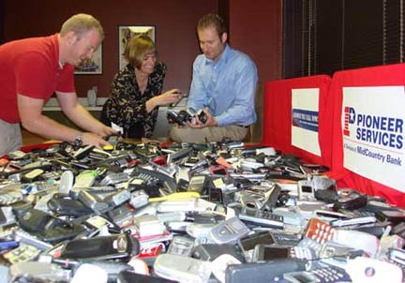
MidCountry Financial Corp. is a financial services holding company with subsidiaries that deliver high-quality and diversified financial services to targeted markets. These subsidiaries include MidCountry Bank, Pioneer Financial Services, Heights Finance Corp., OFC Capital, MidCountry Investments, and Insurance Planners. Since 2002, its associates have been dedicated to building a high quality financial services organization respected by its constituencies, and characterized by a commitment to the values of integrity, fairness, honesty, excellence, and compassion. For more information, visit www.MidCountryFinancial.com.
MidCountry Financial associates collected nearly 1,600 cell phones during the “Answer the Call Now” campaign. The phones will be recycled for cash, and proceeds will benefit USA Cares’ Combat Injured Program
###
Contact:
Scott Cahill
Public Relations, Pioneer Services
media@pioneerservices.com
ph: 816-756-2020
fax: 816-561-9333
All loan applications subject to our credit policies. No official US military endorsement is implied. MidCountry Bank is a member FDIC.

