Non-Surgical Treatments Rise As Frowns Fall


Released on: June 02, 2009, 9:20 am
Author: The Hospital Group
Industry: Healthcare
Recent reports show that Brits are increasingly spending more money on their looks. Therefore it’s no surprise that plastic surgery clinics have reported an increase in non-surgical procedures such facial peels, fillers and Botox®.
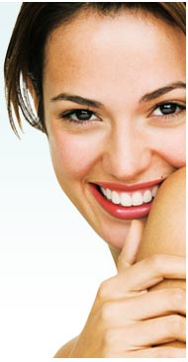
Botox® is just one of many procedures which has increased in popularity over recent years. Many high profile celebrities such as Britains Got Talents, Amanda Holden and Simon Cowell are big Botox® ambassadors, having several sessions a year.
The treatment itself involves the injection of purified protein into the chosen area, which then reduces the activity of the muscles that cause the formation of wrinkles over time.
Botox® has now been taken a step further and can even prevent excess sweating, also known as hyperhidrosis. A series of injections in the treated area, usually the underarm, will gradually decrease levels of perspiration until it practically stops for the next six months.
Recent studies have shown that despite the credit crunch hanging over our heads, it hasn’t affected the growing demand for non-surgical procedures such as Botox®, facial fillers and chemical peels.
The Hospital Group, one of the country’s leading cosmetic surgeries, provides a vast number of non-surgical treatments across its 19 clinics throughout the UK.
The Group saw an incredible 226 per cent increase in the number of non-surgical procedures performed in 2008. A total of 5,200 treatments were carried out across the group last year with treatments such as Botox®, hyperhidrosis and skin peels risingin popularity.
Since The Hospital Group was established in 1992, it has grown from a small pharmaceutical company to one of the UK’s foremost cosmetic surgery providers. The Group is committed to providing the very highest standards and all procedures are performed by an expert medical team in state-of-the-art facilities that are second to none.
Contact Details: For further information on The Hospital Group’s range of surgical and non-surgical procedures please visit thehospitalgroup.org or call 0845 762 6727.

