npower Achieve A Coveted Big Tick Award For Spreading Warmth
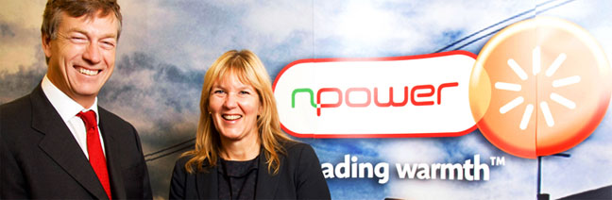

Released on: June 24, 2009, 9:21 am
Author: Vicci Mace
Industry: Energy
npower achieve a coveted Big Tick Award from Business in the Community (BitC) in the Marketplace Impact category, for its 'Spreading Warmth' programme, which is helping to alleviate fuel poverty across the UK.
npower, has helped more than 150,000 customers benefit through the programme; providing financial support, including npower's social tariff and help with outstanding energy debts, as well as energy saving advice over the phone and in the home which has
helped change consumer behaviour to use energy more efficiently.
npower has trained its staff to identify and assist its vulnerable customers, promote assistance available through a range of marketing campaigns and through engagement with external stakeholders developed a targeted programme which provides meaningful help to its customers most in need.
The initiative received the P&G Responsible Marketing and Innovation award for the second year running, and involves training employees to recognise those most at risk, including identifying customers who pay more than 10% of their income on energy bills.
In addition to the Big Tick award, npower has achieved Platinum status in the BitC's Corporate Responsibility Index, the UK's leading voluntary benchmark of corporate responsibility.
Paul Dear, programme manager at npower, said: "Being acknowledged in both BitC's Big Tick awards and Corporate Responsibility Index is a huge achievement.
"In total, we have received three Big Tick Awards throughout the company, and protecting vulnerable and fuel poor customers' is at the heart of our business ethos. The Spreading Warmth programme demonstrates how, as one of the UK's largest utility companies, we operate responsibly and seek to develop personal relationships with customers.
"Our advisors are trained to offer sensitive advice to customers, with a specific focus on recommending the correct tariff and suitable repayment methods."
The Big Tick is awarded to businesses which are able to demonstrate significant impact and high quality management of their responsible business practices, as Stephen Howard, chief executive at Business in the Community, confirmed: "The Big Tick is now recognised as both a valuable and difficult award to achieve.
"Those who achieve the Big Tick are leading companies, ones that run their businesses aware that they depend above all on the talent, innovation and loyalty of their people. They know that they cannot build a successful sustainable business without constantly showing their commitment to being a better business," he added.
Ends
Editors Notes:
About npower:
RWE npower has been awarded the prestigious Community Mark from Business in the Community (BitC). npower is the only utility business, amongst 21 other companies in the UK, to receive this accolade. The Community Mark is a new BitC standard, created to recognise companies that are good investors in local communities and who have brought about real and positive changes
- npower received three awards in the 2009 Big Tick Awards for its impact in the workplace, community and marketplace.
- BitC's Corporate Responsibility Index is the UK's leading voluntary benchmark of corporate responsibility. This year, 141 businesses participated, with seven companies achieving the new Platinum Plus level
Issued by Freshwater UK on behalf of npower
For further information:
Vicci Mace
Freshwater UK
The Waters Edge
Birmingham
West Midlands
B1 2HL
0121 633 7775
www.npower.com

