Patterson Fan Performance with the Convenience of a Shop Floor Fan

Released on: June 9, 2009, 4:27 am
Author: Chris W Smith/Patterson Fan Company, Inc
Industry: Industrial
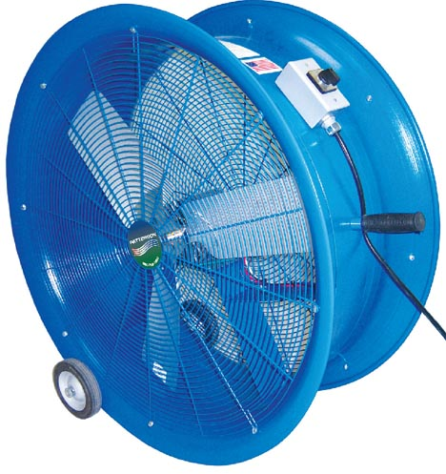
March 1, 2009 – New, Patterson Shop Floor Fans 30” and 34” are suitable for continuous operation in industrial/warehouse environments. Units allow you to control your air flow with 3-speeds; 30” up to 7,500 CFM - 34” up to 10,000 CFM. Shop Floor Fans feature durable welded steel hulls, baked on tough powder coated finish, quality Marathon motors, 115V, with easy to maneuver semi-pneumatic wheels. Expect Patterson Fan quality - built tough for years of use. New Shop Floor Fans are proudly manufactured in the USA.
Patterson Fan Company Inc, located in Blythewood, SC 29016, is currently celebrating 20 years of being the leading manufacturer of high velocity fans. Patterson has revolutionized the way industries regulate their building’s air flow, saving untold amounts of precious energy in doing so.
For more information about the new Shop Floor Fans or any of our other ventilation fan products visit: www.pattersonfan.com.
Contact Details:
Christa Smith
christas@pattersonfan.com
800-768-3985 ext. 102
Cell: 803-629-6325
www.pattersonfan.com

