Sandbox Couture Makes a Splash this Summer with Adorable Swimwear for Kids
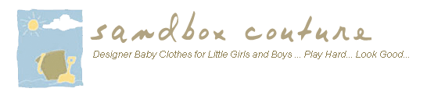
Released on: June 18, 2009, 7:46 am
Author: SandboxCouture.com
Industry: Apparel & Fashion
Online children’s boutique offers the hottest pool side and beach styles this season
Rancho Santa Margarita, Calif., June 2009 -- Sandbox Couture.com, a popular online children's boutique retailer of baby clothes, girls clothes and baby gifts, introduces Summer 2009 swimwear for boys, girls and infants, with a focus on fun, seasonal prints and colors. In addition to new swimsuits, SandboxCouture.com offers a year-around selection of hip, stylish children’s clothing including organic baby clothes and a large selection of designer baby clothes.
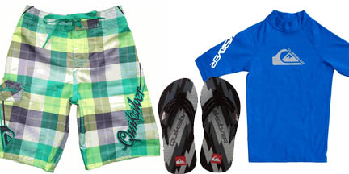
"The long summer days ahead are always eagerly anticipated and what better way to ring in the season than with a new swim suit," stated Sam Brown, spokesperson for Sandbox Couture. “Some of the fondest childhood memories are created during the summer, around the pool or at the beach. Little ones love being outside and in the water, so why not get a couple of bathing suits: one to wear while the other is drying.”
Cool, surf-scene inspired board shorts are paired with UV 50+ rashguard from Quiksilver. From island motif to jigawatt and 80’s style ripper shorts, SandboxCouture.com is the place for toddler and infant boys swim suits, flip flops, hats and accessories. Equally charming and adorable are the little girls bathing suits in one- and two-piece styles from Kate Mack and Kate Mack by Biscotti. Add a pair of flowery pink sandals to give princesses the perfect ensemble for playing and looking good poolside.
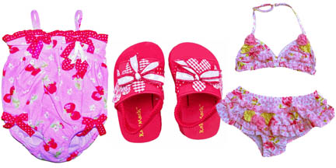
Known as the source for quality children’s clothes and couture fashions for babies and children, Sandbox Couture has provided busy parents -- and a loyal following of couture shoppers and celebrity moms -- a convenient outlet for quality, value and fashion savvy designs for little boys and little girls. Sandbox Couture has developed a reputation for offering couture children’s fashions, at prices that parents will appreciate. From unique designs to the hottest trends, Sandbox Couture's collection of designers offers the convenience of online shopping and the benefits of online savings.
Sandbox Couture is now serving the global community with its fashion forward trends and name brand selections. International shipping rates apply. For additional details, please visit www.sandboxcouture.com.
About Sandbox Couture
Sandbox Couture is an online children's boutique retailer, providing baby clothes, baby gifts and unique children’s clothes. The company takes pride in hand selecting products from top designers, thereby ensuring quality and contemporary style. Sandbox Couture’s philanthropic contributions and socially conscious business practices are at the forefront of the company’s ideals and corporate culture. Founded in 2005, Sandbox Couture is privately held and headquartered in Rancho Santa Margarita, CA. For information about Sandbox Couture, please visit the company's web site at http://www.SandboxCouture.com.
###
Contact Details: Sam Brown
949-459–2505
pr@sandboxcouture.com

