Styles Checks™ goes back to high school with the Pink Ladies from Grease


Released on: June 29, 2009, 5:11 am
Author: Stephanie Demetriou/Styles Checks
Industry: Financial
With hundreds of assorted designs for every collector, Styles Checks continues to expand and incorporate more designs to appeal to the many tastes of its consumers. With the addition of the new “Grease” design, Styles Checks gets a sassy addition to its current collection of check designs.
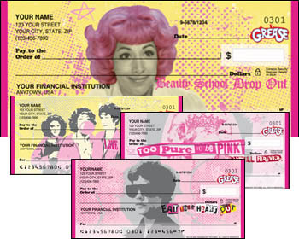
In June, 2009, Styles Checks released the new “Grease” product suite through its website, www.styleschecks.com. The personal checks offer four rotating scenes that feature some of the Pink Ladies individually and then one of them as a group. Against backgrounds of pink and yellow, each rotation features a quote typical of the Pink Ladies. “Eat your heart out” appears with Rizzo, “Beauty school drop-out” is written below a pink-haired Frenchie, “Too pure to be pink” is portrayed with Sandy, and the group shot features the words, “Love us or hate us.” The personal contact cards also feature the group picture of the Pink Ladies while the self-adhesive address labels feature six rotating scenes of the above quotes plus the Pink Ladies and Grease logos. Finally, the checkbook cover is black with pink accents that include the Grease car logo.
The addition of the new “Grease” design allows Styles Checks to appeal to the preferences and collections of even more customers. Styles Checks offers designs for checks and banking accessories that speak to the interests of every collector, hobbyist, or enthusiast.
About Styles Checks:
Whatever interest, hobby, or collection you may have, Styles Checks is sure to have something for you. Including checks that feature our favorite personalities, colorful designs, and famous brands, Styles Checks is certain to have something you can fall in love with! Visit our site to make your daily banking routine a little more interesting!
TM & © 2009 Paramount Pictures. All Rights Reserved.
Contact Details: 1802 Fashion Court
Joppa, MD 21085
410-679-3300
410-676-3300 (Fax)
sdemetriou@cdi-us.com
http://www.styleschecks.com

