Telecom Expense Management Industry Association (TEMIA) Reports 20% Growth and It Begins International Expansion
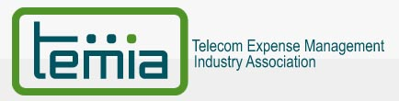

Released on: June 3, 2009, 11:28 am
Author: TEMIA
Industry: Management
The Telecom Expense Management Industry Association (TEMIA) (http://www.temia.org), the authoritative voice for the Telecom Expense Management (TEM) industry, today announced that five new companies have joined the association. More new member signings are expected with recent program expansion and a reduction of membership fees that demonstrates the financial strength of TEMIA.
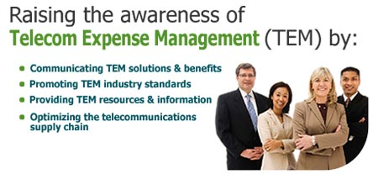
In today’s cost conscious environment, enterprises are actively seeking help from TEM providers. “A TEM provider's membership in TEMIA should be a strong consideration for any organization evaluating TEM solutions. TEMIA membership indicates thought leadership, an investment in the future of effective TEM solutions, and a long term commitment to the TEM market,” said Al Subbloie president and CEO of Tangoe (http://www.tangoe.com) one of the original founders of TEMIA.
The TEM market is growing as more organizations learn about the opportunity to improve supply chain management for telecom expenses and reduce expenses through optimizing inefficient processes. “TEMIA is ideally positioned to drive adoption of key performance benchmarks and metrics across the industry. We are eager to contribute to that effort in a meaningful way,” said David C. Snow, Vice President, Customer and Field Operations for Cerylion (http://www.cerylion.com).
While many of TEMIA members are competitors, they recognize the value that an association can bring. TEMIA is well positioned to help enterprises and TEM providers by developing industry standards for electronic bonding, electronic billing, and augmenting overall service quality. “TEMIA is the foremost organization leading the efforts of creating awareness for Telecom Expense Management at enterprises. It provides a platform to discuss telecom billing issues and standards. It also provides a framework for members to improve the overall TEM industry," said Pankaj Gupta (PJ) President and CEO of Amtel. (http://www.amtelnet.com).
TEMIA occupies a niche that does not compete with other analysts or firms that offer educational programs. “We believe that our joining TEMIA is essential to our business future for two reasons: to cooperate with and learn from respected competitors and to work more closely to insure that the TEM industry develops real industry metrics to better service all clients,” said Joseph B. Chopek, President, Avalon Global Solutions Inc. (http://www.avalonglobalsolutions.com)
“The number of providers that offer some form of a TEM or TLM solution keeps growing; end-users need industry standards to assess and evaluate the viability of these solutions. I am encouraged by TEMIA's accomplishments over the past twelve months towards its mission of developing and promoting industry standards. TEMIA is now well positioned to guide this growing industry for years to come,” said Troy McCracken CEO of Spectrum, Inc. (http://www.3spectrum.com)
The association is also expanding overseas with the recent addition a member with headquarters in France and new signings expected from other firms based in Europe, Latin America, Canada, India, and Asia. “We joined to learn from other companies, share our practices, and help promote TEM standards in Europe,” stated Shahram Sharif, Vice President of Global Strategy and Business Development, for Anatole (http://www.anatole.fr).
“TEMIA is shaping the future of the industry, and we are pleased these organizations have decided to join us in that effort,” said David C. Perdue, TEMIA membership chairman and CEO of Asentinel (http://www.asentinel.com).. “As the authoritative voice for the TEM industry, TEMIA offers companies significant resources and advocacy, while educating potential customers about the value of TEM.”
###############
TEMIA, the Telecom Expense Management Industry Association, was founded in late 2006 by the country's largest Telecom Expense Management (TEM) service providers that cumulatively manage $31 billion of telecom and data spend. TEMIA's mission is to raise awareness and knowledge of the benefits of TEM solutions, to improve the quality and value of TEM solutions through the development and promotion of industry standards, and to cultivate shared industry knowledge among TEM providers, business partners, telecom service providers, and enterprise clients. For more information about TEMIA, please visit, http://www.temia.org/ or contact info@temia.org
Contact Details: TEMIA
info@temia.org
www.temia.org
973 763-6265
1311 South Route 59, Suite #201
Naperville, IL 60564

