The Children's Mutual Reveals Dads Are Kids' Number One Heroes


Released on: June 19, 2009, 8:35 am
Author: The Childrens Mutual
Industry: Financial
Leading Child Trust Fund (CTF) provider, The Children's Mutual, has revealed that Dads are their children's number one heroes, fighting off stiff competition from super heroes, fairy tale princesses, alien fighters, cartoon explorers and world footballer of the year, Ronaldo. This new research from The Children's Mutual has been released to mark Father's Day.
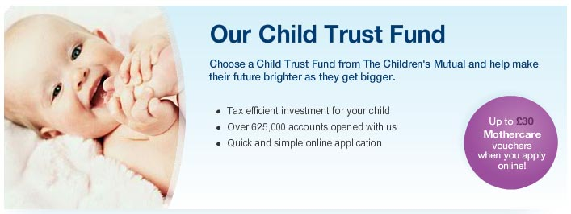
The company spoke to 1,000 of its customers to find out who their children most admired and see how aspirations change over time. For five and six-year-olds, Dad topped the poll for both girls and boys. Mums also fared well, being runner up in the hero stakes for girls and finishing fifth for boys - well ahead of Superman and Batman.
Both Grandma and Granddad also feature in the children's top 10 hero list, with Grandma finishing 10th for girls and Granddad securing ninth spot for the boys, demonstrating the importance of the extended family for today's young children.
Tony Anderson, Marketing Director at The Children's Mutual, said: "Being a great dad can feel like a superhuman challenge and it's wonderful that today's five and six-year-olds can see past the special effects and costumes frequently found in children's popular fiction to appreciate their own home grown hero - Dad".
"Every dad wants to do the best they can for their children and one small part of this is planning for their futures - particularly if they are not going to automatically come into a Bruce Wayne sized inheritance. This is where we hope we can help. By saving money regularly into a Child Trust Fund, families can give their children a financial head start in life - by saving £24 a month into their CTF account from birth, the fund could be worth £9,700 by the time they turn 18. This increases to a potential £37,000 if the maximum £100 a month is invested - an enormous help towards covering university fees or paying for the deposit on a first home."
For further information visit The Children's Mutual.
- ENDS -
Notes to editors:
The findings come from The Children's Mutual's annual 'What I want to Be When I Grow Up' research. Parents of 1,000 children aged five and six were interviewed in 2006 and 2007 to track how their aspirations change over time.
Future projected values quoted based on investing £24 or £100 a month (plus £250 government vouchers at birth and age 7) for 18 years in a stakeholder CTF account. Assumed investment return of 7% a year, with charges of 1.5% of the CTF account value each year. Projected values cannot be guaranteed as shares can go up or down. Final payout could be more or less than this.
About The Children's Mutual - Home of the Child Trust Fund
The Children's Mutual's mission is to help family and friends fulfil their hopes for today's children. The Children's Mutual is now the choice of 1 in 4 parents for their child's Child Trust Fund, looking after more than 650,000 CTF accounts. The Children's Mutual made a significant contribution to the Government's Child Trust Fund consultation process and has won the The Moneyfacts Award for Best Child Trust Fund Provider every year since its 2006 launch.
The Children's Mutual is widely recognised by the business community and press as the industry expert, with financial institutions and family-focused high street retailers including ASDA, Boots, The Co operative, Lloyds TSB, Mothercare and regional bank and building societies across the UK choosing The Children's Mutual's as their CTF partner.
Contact Details:
PR Contact:
Katie Donlan
Senior Account Executive
Consolidated PR
22 Endell Street
London
WC2H 9AD
020 7781 2376
www.thechildrensmutual.co.uk

