Tracesmart Affiliate Program Thrives During First Quarter

Released on: June 5, 2009, 8:19 am
Author: Tracesmart
Industry: Retail
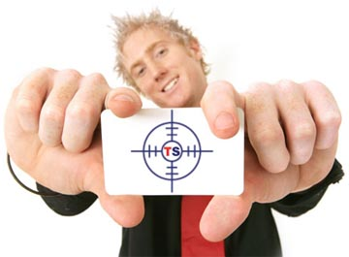
Tracesmart provides an online people search search facility which enables visitors to trace family or friends via the electoral roll, or locate people they have lost contact with via a simple address search. The recently launched affiliate program works alongside the company’s other marketing activity, to further promote these services. The program is delivered and administered by the award winning Deal Media Group, a leading online marketing company which offers a platform for affiliate sales networks, referral tracking and productivity reporting to many major UK companies.
Matthew Hopkins, Internet Marketing Executive explains, "Tracesmart's affiliate program operates by generating income from people looking to find relatives or friends. The affiliate partners agree to display a Tracesmart banner within their website and, in return, they are remunerated when they refer a visitor to Tracesmart who goes on to make a purchase. This practice is common among many companies aiming to increase their company profile and website visitor numbers. The results to date are extremely encouraging."
Having recognised the importance of accessible research tools, Tracesmart developed their database and search facility to provide users with a reliable means to trace people. This ability to perform an electoral roll search from the comfort of one’s own home, has caught the imagination of many website owners, who have in turn become Tracesmart affiliates and are driving the success of the campaign.
"We are always looking for new ways to engage with our target audience, and affiliate programs make it possible to reach a larger number of potential customers," comments Owen Roberts, Tracesmart's Communications Manager, "Tracesmart's search facility has helped many families and individuals and we are confident that visitor numbers will rise even further thanks to our new affiliate program."
About Tracesmart:
- Matthew Hopkins has worked within the field of Internet Marketing since 2002. He is currently responsible for driving high volumes of traffic to the Tracesmart website through SEO, PPC, Social Networking campaigns and, more recently, the company's affiliate program.
- Owen Roberts has worked in the creative, advertising and communications industries for over 25 years and is the voice of Tracesmart. Heading up the communications team, he raises public awareness of the company through various media driven PR campaigns.
- Tracesmart Limited - Since the launch of its website in 2004, Tracesmart Limited has established itself as one of the UK's leading providers of online people tracing tools. www.tracesmart.co.uk combines state of the art search technology with an extensive collection of consumer data, providing one of the most powerful and successful people tracing services in the UK.
Contact Details:
- Contact: Owen Roberts
- Tracesmart Ltd
- 2 Sovereign Quay
- Havannah Street
- Cardiff
- CF10 5SF
- Tel: 029 2047 4114
- Email: owen.roberts@tracesmart.co.uk

