Water Cooler Supplier Eden Springs Launches Online Hydration Calculator


Released on: June 24, 2009, 8:28 am
Author: Eden Springs UK
Industry: Food & Beverage
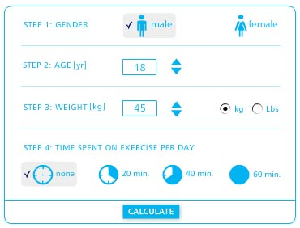
Eden Springs, the UK's leading water cooler supplier, have just released a new hydration calculator that enables people to work out how much water they should be drinking. This online tool calculates your optimum daily water intake by taking into account a person's gender, age, weight and exercise routine. The hydration calculator is available in the services section of the Eden Springs website.
It is commonly accepted that we all require a certain amount of water to maintain optimum health, energy and concentration. It is also reported that most people fall short of this daily requirement. What is less understood is exactly how much water we need.
Everyone is familiar with the '8 glasses a day' or “7 glasses per day” arguments, but these rumours often understate our true requirements and don't take into account the differences in a person's age, weight and lifestyle. On the flip side, drinking too much water is not ideal either so it's important for an individual to learn about their own requirements with some level of accuracy.
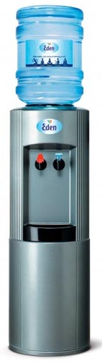
Damien Higgins, Marketing Manager at Eden Springs says "Eden Springs have released this calculator to give existing customers and website visitors a way of working out how many glasses of water they might need and it's a reminder to us all that we should be refilling our glasses as we go about our day.”
“We've also just released a new range of low cost bottled water cooler rental plans, and this calculator helps people to work out how many bottles of water they might need each month for their home or office. Of course, we can also deliver additional bottles to their doorstep at short notice if they find they're running short."
The hydration calculator is a continuation of Eden Springs 'Well-Being at Work' philosophy, which encourages the consumption of water in the workplace to improve health, energy, focus and concentration.
Editors Notes
Eden Springs is a recognised European brand and the leading supplier of bottled and plumbed-in water coolers in the UK. Based in Glasgow, they supply and service 130,000 water coolers held by more than 80,000 customers across the country. To learn more about Eden Springs, or to view a complete range of water coolers, please visit EdenSprings.co.uk
Contact Details: Damien Higgins
Marketing Manager
Eden Springs
3 Livingstone Boulevard
Blantyre
G72 0BP
Tel: 0844 800 33 44
E: damien.higgins@uk.edensprings.com

