Win One Of Two Weekend Trips Away Courtesy Of Sweatybetty


Released on: June 16, 2009, 4:35 am
Author: SweatyBetty
Industry: Apparel & Fashion
The UK is in full summer swing and Sweatybetty has recently released a new glamorous summer and beach wear range for fit and healthy females. The new striking beach wearcollection sees the arrival of several stylish statement pieces and outfits for the uber active. The beach wear collections have something for everyone, longer length tankinis, bandeaus, three way tops, gorgeous halter bikinis, under-wire options, padding and larger cup sizes help to ensure a perfect fit. Nevertheless, the really exciting news is the arrival is the new and improved Fitflop. Last year Sweatybetty helped in creating the popularity attached to the Fitflop.
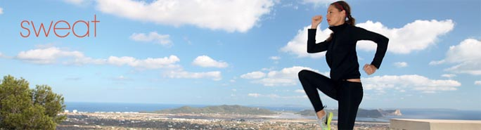
The sports and leisure fashion brand are renowned for its collaboration with the cult brand fitflops. For those who are not yet aware, TEXT Fitflops are a new, innovative and fashionable footwear sandal which will tone legs and bum whilst on the move. Fitflops are a great way to get fit and look great without stepping foot in the gym. Fit Flops are available at Sweatybetty in a range of colour, designs and sizes. Fitflops are engineered with a safety tapered varying density mid-sole that creates a micro wobbleboard workout in every step. Furthermore, the Fit Flop's uniquely built multi-density midsole activates muscles mid-step to help tone thighs, calves and gluteus maximus.
The new and exclusive black and white Walkstar III features dynamic topstitching, streamlined leather upper and a soft microfiber lining for maximum comfort across the instep. Like all fitflops they are built with the patent-pending ‘microwobbleboardTM’ mid-sole technology. This technology is proven to load and work a range of muscles more effectively when wearing them on the move. Fitflops are idea for any individual, male or female that may not have enough time to regularly go to the gym. The advanced technology makes these sandals an idea substitute for the gym, perfect for those individuals regularly on the move and looking to stay fit, toned and lean.
SweatyBetty’s fantastic offer to win a magnificent weekend break, all expenses paid is only available for a limited time. Every pair of Black and White Walkstar III sandals features a street plan of a major city on its sole. If guessed correctly, a weekend trip is up for grabs. Just answer the simple question, which city's street map is featured on the bottom of the black and white Walkstar III sandal by Fitflop? If answered correctly the lucky winner could be jet setting off on a luxury break to that city, with flights, accommodation and a whopping £500 spending money all included. The competition is open to all United Kingdom residents.
To enter this competition visit SweatyBetty online
Contact Details: 833 Fulham Road
London
SW6 5HQ
0800 169 3889

