Deep-rooted Legends, a Tender Love Story, and the Bear Lake Monster is focus of New Novel

Released on: August 6, 2009, 6:40 am
Author: Linda Weaver Clarke
Industry: Media
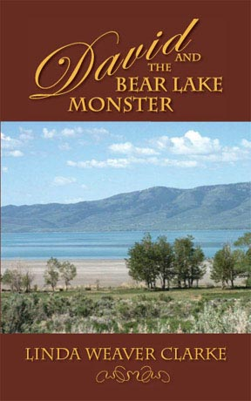
Enter the world of “Make Believe” and read about the legend of the Bear Lake Monster, long family traditions, a tender love story, and a few mysterious events!
Scotland has the Lock Ness Monster and Bear Lake Valley has theirs. Do they really exist? The mystery of the Bear Lake Monster has been an exciting part of Idaho history since the early 1800s. David begins to wonder about this legend in “David and the Bear Lake Monster” (ISBN: 978-1-58982-532-1). As the waves splash gently upon the shore and the full moon shines brightly upon Bear Lake, a deep foreboding is in the air and the fawn, sipping from the lake, can sense it. His ears perk up and he stands still. Only the sounds of nature can be heard, but the deer senses that he is in danger and quickly darts away. A few feet from shore, the water abruptly parts and exposes a gigantic brown lump about 90-feet long. Water trickles down its sides as it floats in the stillness of the night.
Midwest Book Review wrote: “With a blend of romance, this deftly written historical fiction series is well deserving of a place in community library historical fiction collections.”
When David returns to the Robert’s family for a visit, he learns about the great Indian legend: the Bear Lake Monster. When he discovers people still believe in this legend, he sets out to prove that it doesn’t exist but the community is insulted that anyone would try to discredit something they have believed in for years. Their legend is sacred to them and part of Bear Lake history. Searching for true happiness, David is reunited with the Roberts family, trying to overcome his troubles! David quickly becomes one with the town and its folk. He finds himself entranced with one very special lady and ends up defending her honor several times. She isn’t like the average woman. Sarah is different. This beautiful and charming woman has a disability that no one seems to notice. He finds out that Sarah has gone through more trials than the average person. She teaches him the importance of not dwelling on the past and how to love life. After a few teases, tricks, and mischievous deeds, David begins to overcome his troubles. As time passes, he realizes he must now face the dilemma of choosing between his work and matters of the heart.

“David and the Bear Lake Monster will keep readers entertained right up to the last page,” wrote Kim Atchue-Cusella of Book Loons. “Linda Weaver Clarke creates another winner with this installment of her Family Saga in Bear Lake Valley series.”
About the Author
Linda Weaver Clarke was raised on a farm surrounded by the rolling hills of southern Idaho. She now makes her home in southern Utah among the beautiful red mountains. Clarke travels throughout the United States, teaching a “Family Legacy Workshop,” encouraging others to turn their family history and autobiography into a variety of interesting stories. Clarke is the author of the historical fiction series, “A Family Saga in Bear Lake, Idaho,” which includes the following novels: Melinda and the Wild West - a semi-finalist for the “Reviewers Choice Award 2007,” Edith and the Mysterious Stranger, Jenny’s Dream, David and the Bear Lake Monster, and Elena, Woman of Courage.
“David and the Bear Lake Monster” (ISBN: 978-1-58982-532-1, American Book Publishing, 2009). For more information, visit www.lindaweaverclarke.com. Publicity contact:www.american-book.com.
~~~~~

Press release distributed via EPR Network (http://express-press-release.net/submit-press-release.php)

