Chem-Dry Quality Care’s Investment – Promotes Healthier Indoor Air Quality And Helps To Provide Some Relief For Allergy Sufferers
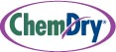

Released on: October 28, 2009, 5:21 am
Author: Chem-Dry Quality Care
Industry: Small Business
With an estimated one in three people in Britain suffering from allergies at some point in their lives and a recent House of Lords report stating that 1 in 5 school children suffer from asthma, indoor air quality is very much a hot topic. It is also estimated that 80% of allergy problems are often caused by the airborne dust mite and they can double their numbers in ten hours. One ideal breeding ground for the dust mite is household carpets and furnishings. However, Trefeglwys based Chem-Dry Quality Care have recently invested in the revolutionary CTS 450 Truckmount cleaning system, which will help in the constant battle to eliminate dust mites, which is good news for allergy sufferers.
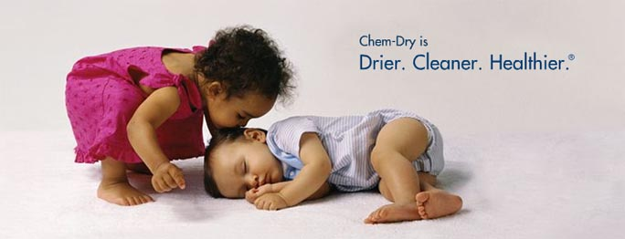
This revolutionary cleaning technology, is a fully self contained system which contains a power unit and pre-heated solution hoses which are fed into the home or business to undertake the cleaning operation.
Chem-Dry’s patented hot carbonating cleaning solution is cleverly warmed from the heat generated by the power unit.
The Carpet & Rug Institute based in the US, who are responsible for undertaking programs to test the effectiveness of carpet cleaning products and represents the carpet & rug industry, recently awarded the CTS 450 Truckmount a gold level ‘Seal of Approval’, the highest accolade for certified deep cleaning systems.
Chris Jones, Proprietor of Chem-Dry Quality Care, comments “If any member of your family is an allergy sufferer, you will understand just how important it is to maintain a good standard of indoor air quality and undertake regular cleaning to control allergies such as dust mites. As a local Chem-Dry commercial carpet cleaner operator I believe it is one of our responsibilities to improve indoor quality in our customer’s homes, neutralise the household dust mite and contribute towards providing a better standard of living for allergy sufferers. I believe truckmount cleaning technology will have a significant impact for our business, our customers and anyone who suffers from an allergy”.
The CTS 450 Truckmount cleaning system is at least five times more powerful than conventional cleaning devices and provides numerous health and safety benefits such as reduced hazards with less manual handling and fatigue placed on technicians as they no longer have to manoeuvre equipment from floor to floor and through customer’s homes to get professional carpet cleaning services.
Chris continues “This is a significant investment for the business and our local domestic & commercial customer base with benefit from improved efficiency savings, reduced downtime by enabling 2 rooms to be cleaned simultaneously and providing superior drying times.
As a local service provider to the North Powys and South Gwynedd communities, I believe it will secure our position in the domestic & commercial market for years to come and we look forward to many more years of raising the standards in our industry”.
Chem-Dry Quality Care became part of the Chem-Dry national network in 2008 and is an independently owned family based business operated by Chris & Vicky Jones. The domestic and commercial carpet and upholstery cleaning business is managed daily by Chris and has evolved through the provision of exceptional service to both their domestic and commercial customers from various parts of North Powys & South Gwynedd.
ENDS
Notes to Editor
Chem-Dry® at a glance www.chemdry.co.uk
• Chem-Dry Quality Care is part of the Chem-Dry® franchise network, which serves 28 million homes. With over 900 licences you are never far away from your local Chem-Dry®.
• Chem-Dry Quality Care has been trading since 2009
• Chem-Dry Quality Care is a locally owned family business
• Chem-Dry Quality Care holds 2 licences, covering communities of North Powys & South Gywnedd
• Chem-Dry® was established in the UK in 1987. Its Yorkshire-based national service centre with 210 staff now supports a network of 900 franchise licences
For further information on Chem-Dry Quality Care, please contact Chris Jones on Tel No 01686 430773 or Mark Richardson on Tel no 01482 888195.
Contact Details: Chris Jones
Chem-Dry Quality Care
Bodaioch Lane
Trefeglwys
Powys, SY17 5PN
chrisjones16@hotmail.co.uk
Tel No: 01686 430773
~~~~~

Press release distributed via EPR Network (http://express-press-release.net/submit-press-release.php)

