Back Rest Pillows – Making Every Chair Compatible With You

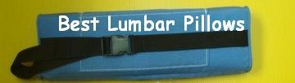
Released on: January 05, 2010, 5:19 am
Author: Debra Botting / bestlumbarpillow.com
Industry: Healthcare
Each of us may have a favorite chair to sit on. More often, we think that a certain chair is more “compatible” with us especially when it makes us feel more relaxed and comfortable. However, the problem is, not all the chairs that we are comfortable in is ours. The thing we are left with is to find other alternatives on how to make our own seats comfortable and relaxing.
One great way of transforming your chair into a precious “throne” is by using one of those back rest pillows.
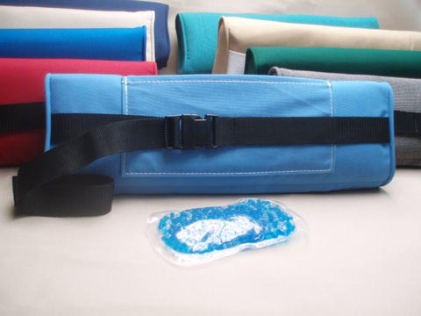
You see, the spine has altered curves which are best supported by special arrangements (say, a pillow) with a certain support at each single point. This way, the lower portion of the back is relieved from carrying too heavy a load. When this is done, the spine gets rest and the its overall health improves. The support received by the spine also gives fast relief to lower back pain.
Using back rest pillows is arguably the best technique to support the spine. These pillows are very flexible and easily mold into the shape of your spine’s curvature. It bridges the gap between your chair and your back which in turn provides you with a whole new restful sitting experience.
Aside from having a restful sitting experience, below are two of the advantages of back rest pillows:
• Flexibility– They are flexible. When you place them between your back and the chair’s backrest, they would fill up any empty space between the two. As a result each point of your spine receives support from the pillow.
• Mobility – These pillows for the back are relatively light. Not like ergonomic chairs, you can carry these pillows around your office, carry in your car, the airplane and other travel destinations. They are not only handy, they are also classy especially those made of Sunbrella outdoor fabric. They are definitely a must-buy if you want to get the most of your money’s worth. With them, you can now make every chair compatible with you!
Lumbar Pillows make a great practical gift for any occasion and for any age group.
An Ice Pack Pouch can be ordered to enhance the Lumbar Pillow for back pain.
These Lumbar Pillows are custom made in my shop in the beautiful Florida Keys.
If you would like to have your own lumbar pillow, click here
Contact Details: Debra Botting, Deb's Dream Canvas
156 Florida Avenue
Tavernier, Florida
33070
(305)394-3747

~~~~~

Press release distributed via EPR Network (http://express-press-release.net/submit-press-release.php)

