Burton Launches Score Draw Competition

Released on: January 14, 2010, 4:30 am
Author: Burton
Industry: Retail
Burton menswear has announced the launch of its Score Draw competition. The Score Draw collection is a retro collection of football shirts to celebrate the great years of footballing champions and cool shirts.
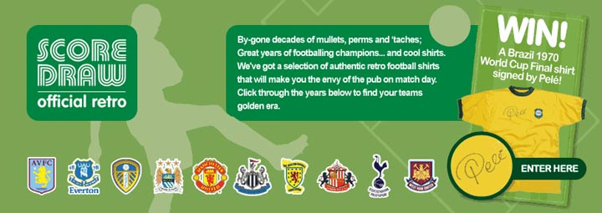
There are 20 shirts available in the collection, covering 10 English clubs: Manchester United, Arsenal, Tottenham Hotspur, Everton, West Ham United, Leeds United, Newcastle United, Aston Villa, Sunderland and Manchester City, plus 4 Scotland shirts soon to be available.
To celebrate this collection Burton is giving the chance to win a T-shirt - a Brazil 1970 World Cup Final shirt signed by the world's greatest ever player, Pele.
This authentic reproduction Score Draw shirt represents the all-time football shirt design classic. Worn by the famous Brazil team of the 1970 Mexico World Cup Final in the 4-1 victory over Italy, the top epitomises the classic encounter of the irresistible force meeting the immovable object as the Brazilian force prevailed and secured a record third World Cup triumph (1958, 1962, 1970).
This Score Draw shirt has been autographed by Edison Arantes do Nascimento, better known as Pele, who played in 92 internationals (scoring 77 goals) for Brazil - including two World Cup Finals.
For a chance to win this signed collectible retro Brazil shirt signed by Pele, entrants just need to fill out a competition entry form on the Burton site. The closing date for this competition is 12 February.
The Score Draw brand is the leading supplier of official retro football shirts in the World.
Score Draw football shirts are officially licensed and endorsed by more than 40 football clubs and national associations accommodating over 600 styles from over five decades. Every Score Draw football shirt is meticulously researched and designed to represent the original garment worn by momentous old teams and players - football shirts fit for heroes - that are widely accepted by football clubs, players and supporters as the definitive reproduction.
About Burton
Burton was originally founded in 1903 under the name The Cross-Tailoring Company. It quickly became popular and expanded into hundreds of outlets and factories across the United Kingdom. Today, it is a staple on most high streets and a popular retailer formen's clothing, including gifts for men, casual clothing and men's hoodies, men's jackets and jeans.
Customers can also shop online from the Burton.co.uk website which offers free returns in-store or by post and fast delivery to their home. The site features a useful size guide to ensure customers can get the correct fit for all items. They can also sign up for the Burton newsletter, which offers all the latest style updates, exclusive discounts and competitions.
For further Burton media information, please contact:
Caroline Rolfe
Burton
Arcadia Group Ltd
Colegrave House
70 Berners Street
London
UK
W1T 3NL
020 7291 2951
www.burton.co.uk
~~~~~

Press release distributed via EPR Network (http://express-press-release.net/submit-press-release.php)

