Catalent Solidifies Inhalation Product Development Capabilities With New Offering

Released on: January 12, 2010, 3:31 am
Author: Jennings and Co.
Industry: Pharmaceuticals
Catalent Pharma Solutions has acquired advanced fine powder filling capability, which solidifies Catalent’s position as a leader in development and manufacturing services to the pharmaceutical inhalation sector. With the purchase of Harro Höfliger’s Omnidose filling equipment, Catalent now offers its customers fully scaleable dry powder inhaler (DPI) filling capability. This widely-accepted technology, to be housed in Catalent’s Research Triangle Park, North Carolina facility, provides a flexible platform to reliably support all clinical manufacture through Phase II/III and a scaleable path to higher volume late stage clinical and commercial manufacturing.
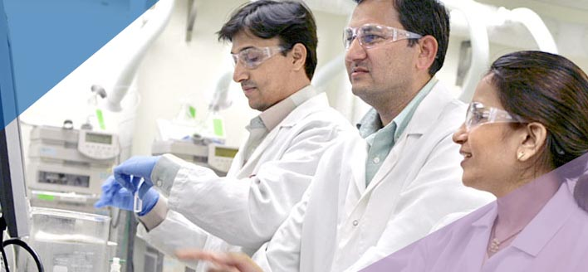
The Harro Höfliger equipment is an advanced technology specialized in powder filling for microdosing, in the 1 – 300 mg of powder range, into an array of DPI formats to include both capsule-based and pre-metered blister device formats. This new capability gives Catalent a full range of pulmonary and nasal services, filling a gap in the marketplace for advanced powder filling capabilities. Catalent will now be able to serve as a one-stop-shop for the development of all inhalation dosage forms, possessing both the capital assets and technical experience. This recent addition complements Catalent’s pre-existing automated pMDI infrastructure.
Catalent’s primary location for inhalation product development is in Research Triangle Park, North Carolina where its experienced team offers comprehensive pulmonary and nasal services to help take a product from concept through regulatory approval. Catalent has extensive experience with all pulmonary dosage forms including pMDIs, DPIs, nasal sprays and solutions/suspensions for inhalation. For more information on Catalent’s proficiency in dosage form selection, technology assessment, formulation development, analytical testing and supplying toxicological and clinical trial materials, please visitwww.catalent.com/development.
About Catalent
Headquartered in Somerset, New Jersey, Catalent is one of the leading providers of advanced dose form and packaging technologies, and development, manufacturing, and packaging services for pharmaceutical, biotechnology and consumer healthcare companies in nearly 100 countries. Catalent applies its local market expertise and technical creativity to advance treatments, change markets and enhance patient outcomes. Catalent employs approximately 9,500 at 30 facilities worldwide and in fiscal 2009 generated more than $1.6 billion of annual revenue. For more information, visit www.catalent.com.
Contact Details: Patricia A. McGee
(732) 537 6407
patricia.mcgee@catalent.com
Dan Dunlop, Jennings
Peggy Albertson, Jennings
(919) 929-0225
ddunlop@jennings.com
palbertson@jennings.com

~~~~~

Press release distributed via EPR Network (http://express-press-release.net/submit-press-release.php)

