Digital Asset Management: A Solid Solution for Digital Assets


Released on: January 15, 2010, 4:10 am
Author: Databasepublish.com
Industry: Internet & Online
With or without a downturn in the economy, the management of digital assets is a vital piece of the puzzle concerning efficient and effective organizational processes. The success of an effective content management system brings peace of mind and increased long-term sustainability for organizations.
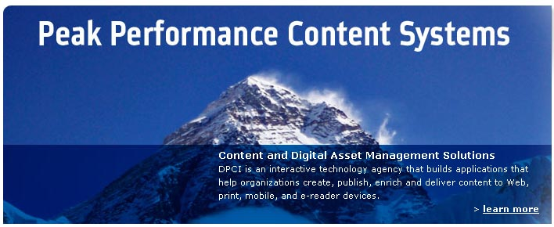
New York, NY January, 2010 – Databasepublish.com - One of the greatest opportunities for many organizations involves the potential streamlining of their content structure for print, mobile or web applications. The time that it takes to structure content for these applications costs many organizations time, money and lost opportunity. A reliable content management system can help to create a competitive advantage in the marketplace.
Many organizations own hundreds of thousands of digital assets. These include corporate logos, branding material, audio and video clips, still and stock photography, and a variety of archival content. Many of these assets were acquired over long periods of time and at great expense to the organization. Unfortunately, many organizations are unable to maximize the benefits of their digital assets due to a lack of an effective digital asset management solution.
Due to the critical nature of having digital assets organized and easily locatable, many organizations have implemented a digital asset management system. These organizations may have a slightly better grip on their digital asset management than an organization with no formal system. However, over time an organization’s needs change, which oftentimes necessitates customization, retraining of staff, and/ or the integration into a content management system or back-office software package.
For this reason, it is important to find consultants that are well-versed in tailoring a new or pre-existing digital asset management system to meet the current needs of the business. For example, an organization may be looking to find a digital asset management system that centralizes and manages the rights and permissions of a significant portion of all published editorial content, containing text, illustrations and photographs. Such a system could help non-technical staff members reuse both legacy and fresh content across print and digital media more effectively. Additionally, the organization may want the final implementation of the the digital asset management solution to be in-house.
For this example, many product options are available in the digital asset management market. Although the organization knows what capabilities they want, a prudent decision would require an interactive technology agency that can deliver an integrated content management system to help the organization refine its requirements and manage the request for proposal process.
A third-party consulting business that understands the technology, can assist in the refinement of requirements, and ensure an objective selection of vendors is indispensable. The mark of a truly valuable consultant is in their ability to quickly distill an organization’s needs for digital asset management and not only help identify the appropriate vendor, but also provide a new way of thinking. The type of thinking that helps the organization ensure they get the most out of their investment through the implementation of the digital asset management system.
The type of experience necessary for this kind of insight comes from a consulting business that consults, tailors and implements content management systems and digital asset management solutions across a wide-range of industries. For some organizations, a content management consultant is most appropriate for the entire process, while for others a reliable consultant can help match the organization’s needs with the right vendor and help prepare the organization for their ultimate digital asset management system.
About DPCI:
DPCI consults with businesses to find the right content management system. They have a 10-year track record of helping diverse organizations find digital asset management solutions in a wide-range of industries. DPCI has the professional and technical requirements necessary for consulting, providing, tailoring, as well as, completely implementing successful digital asset management system.
Contact:
1560 Broadway, Suite 810
New York, NY 10036-1518
800)-818-2905
http://www.databasepublish.com/contact
~~~~~

Press release distributed via EPR Network (http://express-press-release.net/submit-press-release.php)

