Hazmat Training Comes to Indianapolis


Released on: January 12, 2010, 3:26 am
Author: Environmental Resource Center
Industry: Environment
January 12, 2010 – When workers handle hazardous waste or ship hazardous materials, training is not just a good idea, it’s the law. According to the EPA, workers who handle hazardous waste must be trained annually, and the federal DOT requires that workers involved in the shipment of hazardous materials be trained at least every three years. Personnel who ship hazardous materials by air or water must receive training mandated by the International Air Transportation Association (IATA) and International Maritime Organization (IMO) every two years.
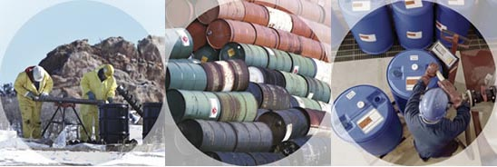
Environmental Resource Center, the leading provider of environmental and safety training, will present the mandatory training in Indianapolis at the Crowne Plaza Hotel – Indianapolis Airport on February 1 – 4, 2010.
Hazardous Waste Management: The Complete Course will be taught on February 1 and 2, DOT Hazardous Materials Training: The Complete Course will be taught on February 3 at the same location, and IATA/IMO will be taught on February 4 at the same location.
Registration for the mandatory training is available by calling 800-537-2372 or at http://www.ercweb.com/classes.
Now in its 28th year, Environmental Resource Center trains not only thousands of industry personnel every year, the company also trains personnel from most of the State and Federal agencies that enforce the regulations.
Contact Details: Malia Campbell
Environmental Resource Center
101Center Pointe Dr.
Cary, NC
919-469-1585; Fax: 919-342-0807
mcampbell@ercweb.com
http://www.ercweb.com

~~~~~

Press release distributed via EPR Network (http://express-press-release.net/submit-press-release.php)

