House of Fraser Introduces New Homeware Collection


Released on: January 29, 2010, 12:31 pm
Author: House of Fraser
Industry: Retail
House of Fraser has launched is latest exclusive homeware collection - Pied a Terre Home.
Pied a Terre has been long established as a footwear brand and paying homage to its roots, the first collection offers a fashion-led range of must-have homeware. Featuring a mix of luxe fabrics, mirrored finishes, bold colour and high shine accessories, the Pied a Terre homeware is an elegant and stylish new addition to the world of Home and the collection is only available at House of Fraser.
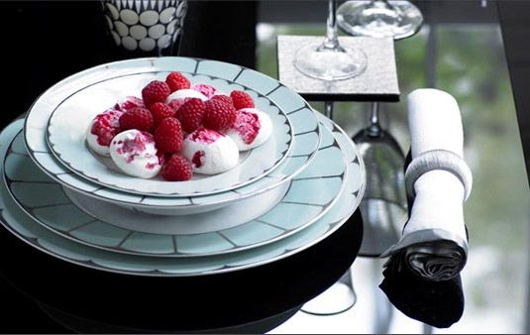
Metallic detailing is key in dining. A touch of gold provides a glam finish on pink and purple patterned dinnerware, while fine gold stripes on white and a simple gold rim on black encapsulates a distinctly sophisticated feel. Silver looks fresh and bright on a cool eau de nil base while gold and black gloss cutlery sits with coloured porcelain dinnerware creating a polished, modern feel.
Layering provides a sumptuous feel to bedlinen. Luxurious throws and embellished, ruched and embroidered cushions add the finishing touches to the designs. A soft-grey herringbone pleat design is perfectly coordinated with matching cushions and a dove-grey headboard for super-chic style. For a feminine feel an embroidered chinoiserie design in shades of pink will brighten any bedroom, while a simple white ruffle design offsets with black to add a harder edge.
In furniture a slick range of black lacquer tables, shelving and cabinets provide a high-gloss base for statement dinnerware and home accessories in bold colours. For a refined look a black glass-topped side table with mirrored legs makes a delightful surface for soft grey accessories and eau de nil dinnerware. Upholstery takes inspiration from the latest catwalk looks featuring a selection of different fabrics and colours. A soft-grey cotton sofa is a piece for any modern living space while a sumptuous deep purple design adds richness to a simple low-key setting. For a smaller piece of furniture, a soft-red velvet armchair sits perfectly with a simple black floor lamp while a soft duck egg chaise lounge looks effortlessly elegant with a single pink cushion.
Pied a Terre Home is exclusive to House of Fraser and shoppers can take a sneak preview of the collection through the House of Fraser website and order online or make a purchase in store from February.
In addition to the homeware collection, customers can also purchase Pied a Terre shoes both online and in store.
ENDS
Notes to Editors:
About House of Fraser
House of Fraser is a department store group with 62 enviable locations across the UK and Ireland and a fully transactional website. As one of the best known names on the high street, House of Fraser has presented customers with an unrivalled nationwide department store for more than 160 years. The company was acquired by the Highland consortium in November 2006 marking the beginning an exciting new chapter in its history. The group has annual sales in excess of £1.25bn and employs 6,500 House of Fraser staff and 10,000 concession staff through 5 million sq ft of selling space. House of Fraser not only stock Pied a Terre homeware but also sell Pied a Terre women's shoes
and other clothing ranges for men and women.
House of Fraser media contact:
Rea Shahroudi
Online Acquisitions Manager
House of Fraser
27 Baker Street
London
W1U 8AH
020 7003 4650
www.houseoffraser.co.uk
~~~~~

Press release distributed via EPR Network (http://express-press-release.net/submit-press-release.php)

