Locating The Best Suited Alcohol Abuse Treatment For You In California
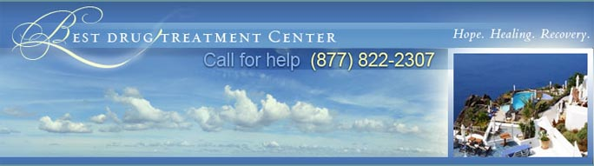

Released on: January 27, 2010, 12:39 pm
Author: bestdrugtreatmentcenter.com
Industry: Healthcare
The best drug treatment center is the one that cares most deeply about its individual clients. Alcohol addiction is a personal problem, and alcohol abuse treatment must be a personal process. If you're going to get sober, it's going to be on your own terms, in a way that's meaningful to you and no one else. The alcohol abuse treatment program that's right for you is the one that can help you do exactly that.


There are plenty of alcohol abuse treatment facilities in Los Angeles. Unfortunately, they aren't all equally committed to meeting the individual needs of their individual residents. On the contrary, many of the most "exclusive" rehabs in California offer the same generic alcohol abuse treatment programs to every patient who seeks their help. As should go without saying, these institutions can't be trusted to produce meaningful or lasting alcohol recovery.
The good news here is that the best alcohol abuse treatment center in Malibu is different. The center's exclusive alcohol abuse treatment programs are designed on a case-by-case basis, with the explicit goal of helping clients heal from the inside-out. That patient-centered approach helps to explain why the center's residents enjoy such a robust rate of success. It should also leave no doubt as to where your interests will be best be served. Successful alcohol rehab will quite literally change your life. Here's hoping you'll be wise enough to learn that truth for yourself.
BestDrugTreatmentCenter.com provides information on one of the best alcohol and drug abuse centers in the world, where treatment programs involve individual privacy, luxury and a unique drug treatment therapy plan. If you'd like more information about a drug or alcohol abuse treatment center for you, please call 1-877-822-2307, visit our website athttp://www.bestdrugtreatmentcenter.com/, or contact us at admissions@bestdrugtreatmentcenter.com.
This press release may be used freely, provided that the resource box is included and the links are active. A courtesy copy of the issue or a link to any online posting would be greatly appreciated.
Contact Details:
http://www.bestdrugtreatmentcenter.com/
admissions@bestdrugtreatmentcenter.com
1-877-822-2307
Malibu, CA 90265
~~~~~

Press release distributed via EPR Network (http://express-press-release.net/submit-press-release.php)

