Old World Gourmet Is Ringing In 2010 With A Little Frost On The Bubbly!!!


Released on: January 15, 2010, 5:10 am
Author: www.creativewebsolutions.net
Industry: Food & Beverage
First it was freezing wine, then it was the Bitch Bags (which, by the way, is their 2nd best selling line ), and now they are freezing champagne!! Old World Gourmet will be debuting their Bellini Frost line at the January 2010 Gift show at Americas Mart in Atlanta Georgia!! They have 3 flavors available at this time, a tropical mango, an apple and a harvest peach with additional flavors on the way! These three powdered mixes all make 1 gallon of positively fabulous frosted bubbly drinks. This is a mix, freeze and stir product line, just like their coast to coast famous frozen wine mix. No blenders, no ice needed which makes their product lines very consumer friendly. Private labeling is also available through Old World Gourmet with very low minimums. There is nothing like these three Bellini Frost Champagne Freeze Mixes....This is truly Champagne at its best! Update your Champagne experience and be a part of the trend for 2010!
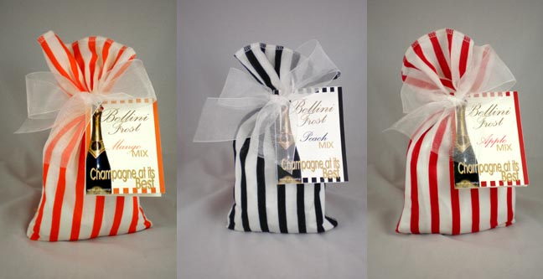
Dan and De'Anna Sullivan started this business on September 11, 2001(yes, that date is correct) with only 2 products and over the last 8 years they have constantly surprised and delighted retailers from coast to coast with their innovative and "out of the box" creativity and product lines. The company now has over 70 products, each one being unique in creation, color, packaging, and flavors. Old World Gourmet has received multiple 1st place awards for Best Packaging, Best Cold Beverage, Best Snack, and Best New Gift Item. Visit their web site at www.owgshop.com and you'll agree that they are way ahead of the curve!
Contact Details: Old World Gourmet Shop
1680 Hiram/Douglasville
Suite 302
Hiram, GA 30141
1-877-466-8889
~~~~~

Press release distributed via EPR Network (http://express-press-release.net/submit-press-release.php)

