President's Call For Jobs and Justice Fuels Rallies By National Black Farmers Association
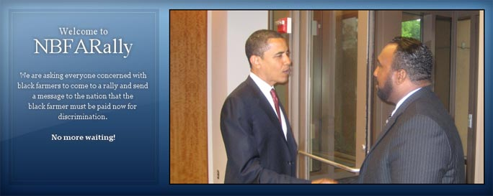
Released on: January 29, 2010, 11:40 am
Author: National Black Farmers Association
Industry: Government
Regional Gatherings Of National Black Farmers Association Will Urge Immediate Action By Congress, President
Washington, DC (January 29, 2010) -- The call for jobs and a renewed emphasis on civil rights in the State of the Union address will echo through upcoming rallies, according to Dr. John Boyd, president of the National Black Farmers Association.
In a series of regional events, black farmers will urge Congress and President Obama to act now on a promised $1.15 billion to remedy decades of discrimination.
“The nation's treatment of black farmers is a blight. Empty promises only make matters worse,” said Dr. Boyd. “It is time for Congress to do the right thing and compensate discriminated black farmers for the government's wrongs against them. It certainly has found the will to fund far less worthy and much more expensive causes. “
Beginning on February 6 in Little Rock, Arkansas, black farmers and supporters from some of the most depressed areas of the country will come together to insist on long promised and long delayed justice. It was back in 1999 that the government agreed to one of the largest civil rights settlements in our history, the Pigford case, due to discriminatory practices by the USDA.
In his State of the Union address, President Obama observed: "We find unity in our incredible diversity, drawing on the promise enshrined in our Constitution: the notion that we are all created equal, that no matter who you are or what you look like, if you abide by the law you should be protected by it; that if you adhere to our common values you should be treated no different than anyone else."
On the other side of the aisle, Governor Bob McDonnell of Virginia found it easy to agree on the subject of job creation.
"We were encouraged to hear President Obama speak this evening about the need to create jobs," said McDonnell. "All Americans should have the opportunity to find and keep meaningful work, and the dignity that comes with it."
But for black farmers, the ideals laid out by both President Obama and Governor McDonnell have been only a dream. Black farmers and supporters will rally throughout the Southeast culminating in a rally in front of the US Department of Agriculture in Washington, DC to make heard the urging of thousands: keep your promise; justice now.
The rally schedule includes:
Saturday, February 6, 2010: Little Rock, Arkansas (The Downtown Hilton)
Monday, February, 8, 2010: Memphis, Tennessee (Handy Park)
Tuesday, February 9, 2010: Jackson, Missouri (Battlefield Park)
Wednesday, February 10, 2010: Montgomery, Alabama (in front of the Capital Building)
Thursday, February 11, 2010: Columbus, Georgia (The Columbus Civic Center)
Friday, February 12, 2010: Columbia, South Carolina (The Clarion Hotel)
Saturday, February 13, 2010: Richmond, Virginia (Downtown Hilton)
Monday, February 15, 2010: Washington, DC (US Department of Agriculture - Jefferson Drive side)
For more information, please contact Billy Warden (919) 412.0630 or visit http://nbfarally.com/.

~~~~~

Press release distributed via EPR Network (http://express-press-release.net/submit-press-release.php)

