RoomPro Technologies Announces New Classroom Technology Solution For Schools


Released on: January 08, 2010, 4:41 am
Author: Mike Matera
Industry: Electronics
Wisconsin Rapids, Wisconsin – (January 8, 2010) – RoomPro Technologies has released RoomPro ONE, a fully integrated, all-in-one classroom control and microphone system that enables K-12 educators to provide an enhanced audio and video experience to improve student learning.
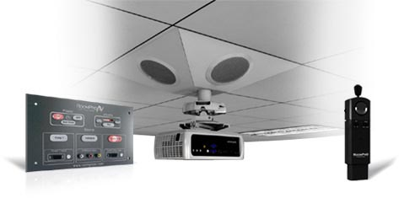
RoomPro ONE is equipped with a built-in infrared (IR) microphone system that offers optimized voice enhancement and 360° sound reinforcement for full-classroom auditory learning. It also includes a wall panel for simple, one-touch control and notably features a Virtual Control Panel, RoomPro’s proprietary control panel emulation software that allows teachers to operate the system using multiple instructional technologies.
Dean Olds, president of RoomPro Technologies, says the system’s patented design offers educators several advantages.
“RoomPro ONE solves the problem of uneven classroom sound distribution and as a result the related problem of uneven learning experiences from student to student. And, with the addition of our Virtual Control Panel, we have found a way to provide educators with more convenient system control and access. Teachers can now quickly and easily operate the system at the touch of a button, whether they are working from a laptop, a wireless tablet or an interactive whiteboard,” Olds says.
Olds adds that the system’s powerful multimedia management and control seamlessly integrates devices educators need while eliminating devices they don’t—such as remotes, which can be cumbersome to use and are easily misplaced.
According to Olds, another critical advantage for educators is that the system is priced with tight school budgets in mind. “Our system is well-positioned to help schools create the classroom of tomorrow within the budget limitations of today. It essentially can be purchased for what you would expect to pay for a classroom microphone system alone,” he says.
Olds says that RoomPro ONE has also been well received by school technology specialists because it is engineered for quick installation. “RoomPro ONE includes a one-of-a-kind, all-metal ceiling enclosure that attaches cleanly to the ceiling and integrates four hi-fidelity speakers, audio amplifier, A/V switcher and projector mount—all in one,” he says. “And since our system is designed to be installed in under an hour, the investment in time and resources is also significantly reduced for schools,” adds Olds.
In addition, RoomPro ONE comes with full audio support and includes multiple audio inputs and an audio output to record lessons and create podcasts to share with others.
RoomPro ONE also includes a full complement of voice amplification options, starting with an IR pendant-style microphone that features an audio input jack for seamless connection to an iPod® or MP3 player or a separate plug-in headset teachers can wear comfortably around their necks if they prefer.
About RoomPro Technologies
RoomPro Techologies is a leading manufacturer of audio and visual products specializing in the K-12 market and is based in Wisconsin Rapids, Wis. Its all-in-one control and microphone systems are found in classrooms, conference rooms and training rooms across the country. More information is available at www.roomprotech.com
Contact Details: Mike Matera
Director of Sales and Marketing
RoomPro Technologies
140 East Grand Avenue
Wisconsin Rapids, WI 54494
(800) 980-3381
mikem@roomprotech.com

~~~~~

Press release distributed via EPR Network (http://express-press-release.net/submit-press-release.php)

