npower Boiler Scrappage Scheme Gets Off To A Flying Start
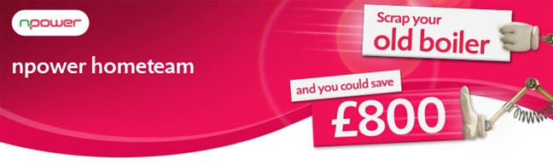
Released on: January 15, 2010, 3:25 am
Author: Nick McHugh
Industry: Environment
npower hometeam has revealed that it has seen a six-fold increase in customers enquiring about replacement or new boilers since the announcement of the Government's boiler scrappage scheme.
Six times more appointments were booked through npower hometeam on the first day of
the Government scheme, compared to the previous day. The company, which installs, services and repairs boilers, has drafted in extra staff to meet the demand while existing staff are working overtime.
In December npower became the first energy supplier to launch its own boiler boiler scrappage scheme, but with the Government announcement consumers could now be eligible to receive as much as £800 towards the cost of a new gas boiler installation as well as saving nearly £235 off an annual gas bill*, when replacing one that is G rated. This week has seen some of its competitors follow npower's example.
npower has also announced that it will honour the full £800 scrappage discount for customers who, due to the cold weather, need to have their broken down 'G rated' boiler replaced before the end of January, subject to availability. This is to help customers who may need a new boiler before the government vouchers are available (January 18th at the earliest).
Kevin Miles, CEO npower retail, said: "As we enter the coldest winter for 30 years, we are finding that the boiler scrappage scheme is really striking a chord with our customers. With the HHIC estimating the average cost of a boiler installation to be around £2,500, £800 is a significant discount.
"We are encouraging any interested parties to act quickly to benefit from the scheme, as the Government has a finite pot of money which will be allocated on a first come, first served basis."
(ENDS)
Notes to editors:
* Source Energy Savings Trust
About npower:
npower has 6.6 million residential gas and electricity accounts throughout the UK. npower is a market leader in renewable energy. Consumers can join the energy industry discussion on npower's interactive debating website - the brighter energy debate, where they can post their questions, views and comments.
Npower hometeam installs, and services boilers, in addition to offering boiler repairs and a wide variety of heating cover options in conjunction with homeserve.
Contact Details: Nick McHugh
Press and Public Relations
npower
Oak House
Bridgwater Road
Worcester
WR4 9FP
0845 070 2807
www.npower.com
~~~~~

Press release distributed via EPR Network (http://express-press-release.net/submit-press-release.php)

