npower Encourages Homeowners To Act Fast To Save Cash
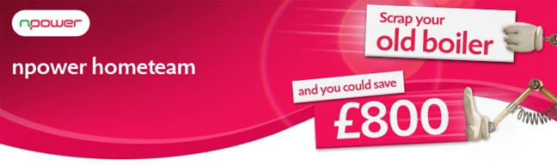
Released on: January 18, 2010, 5:57 am
Author: npower
Industry: Energy
npower has announced that thousands of fast-acting homeowners will be the first in England to benefit from the new Government boiler scrappage scheme as the Energy Saving Trust posts application forms for consumers to claim the £400 discount.
First to receive the details are those who have already registered with the Energy Saving Trust. Thousands of forms are being issued on the first day alone. With only 125,000 grants available on a first come first serve basis, energy company npower is urging homeowners wanting to benefit from the scheme to register quickly to avoid disappointment.
npower was the first energy supplier to launch its own boiler scrappage scheme, matching the Government's offer. This means consumers could be eligible to receive as much as £800 towards the cost of a new boiler when replacing one that is G rated - which could be almost a third off the cost of an installation. npower's offer also extends to any boiler 10 years or older so even if it isn't G-rated, homeowners can still enjoy a discount.
npower hometeam, which installs, services and repairs boilers, has already seen huge interest in the offer and it is expecting more now that Energy Saving Trust mailing has started.
Kevin Miles, CEO npower retail, said: "The scrappage scheme is great news for homeowners and the perfect opportunity to install a new energy efficient boiler to help cut your heating bills. If you want to take advantage of getting £800 off an installation, the important thing is to act fast or you could be disappointed. There's approximately four million G-rated boilers in the UK*, but there's only 125,000 grants available under the scheme. Our advice is don't leave it too late, get it before it's gone."
For more details on the Energy Saving Trust £400 voucher please call 0800 512 012.
For further information on npower's £400 offer please call 0800 0722 999.
Notes to editors:
* Source Energy Savings Trust
About npower:
npower has 6.6 million residential gas and electricity accounts throughout the UK. npower is a market leader in renewable energy. Consumers can join the energy industry discussion on npower's interactive debating website - the brighter energy debate, where they can post their questions, views and comments.
Npower hometeam installs, and services boilers, in addition to offering boiler repairs and a wide variety of heating cover options in conjunction with homeserve.
For media information please contact the npower press office:
Nick McHugh
Press and Public Relations
npower
Oak House
Bridgwater Road
Worcester
WR4 9FP
0845 070 2807
www.npower.com
~~~~~

Press release distributed via EPR Network (http://express-press-release.net/submit-press-release.php)

