Animal Online Store Launches New Season Collections

Released on: February 04, 2010, 5:24 am
Author: Animal
Industry: Retail
Animal, the freesports apparel brand has announced that its new 2010 spring collection has been launched on their online store.
The Animal online shop stocks one of the widest selections of Animal products available in the UK including clothing, watches, bags, footwear, eyewear and accessories.
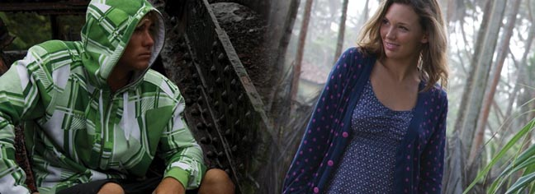
The extensive Animal clothing collection for men, women and children provide many transitional pieces suitable for the early months of the New Year as well as a great swimwear collection perfect for the up and coming summer months. The in-house design team take inspiration from Animal's surf heritage, pop culture and other on trend influences to produce a diverse collection suitable for a wide variety of online shopper.
The Animal men's clothing offers a wide selection of product including t-shirts, shirts and jackets. The Animal hoodies have been nicely updated this season with new graphics and a fresh colour palette ranging from loud bright hues to more neutral tones. Great attention has also been spent on shorts and denim collections with new washes, prints and cuts.
For the Animal women's clothing collection, dresses are a big trend this season with a range of cute beach dresses, floaty floral dresses and smart evening maxi dresses. Layering is also key this year with a lovely selection of cardigans, lightweight knits and check shirts. There is also a fabulous selection of Animal bags to compliment every outfit with prints and detail tying back into the main line clothing collection.
Animal retail buying director Tim Metcalfe commented: "Our new collection moves on from where our winter season left off. With a more progressive, vibrant colour palette for men and a softer, more sophisticated styling for women, the Animal collection is fresh and on trend for 2010. New product areas include the launch of a new "Enjoy not destroy" organic clothing collection, loungewear for lazy summer days and more technical advancements in stretch fabric board shorts."
The online store continues to have exclusive opportunities and competitions for its shoppers as well as free delivery with all purchases over £50, free returns on all orders and a safe, secure shopping online experience.
Animal aligns itself as a lifestyle brand based around a number of core sports including surfing, windsurfing, kitesurfing, bodyboard, mountain bike, BMX, wakeboard, freeski, snowboarding and motorcross. Animal also sponsors key events across these sports and has a team of riders ranging from youth development through to professional.
About Animal:
Established in 1987 in Poole, Dorset, Animal is one of the UK's leading freesport brands specialising in the design, marketing and retailing of freesports influenced clothing, technical clothing, footwear, luggage, eyewear, accessories and watches.
Actively involved within the freesports of surfing, snowboarding, windsurfing, kitesurfing and mountain biking, Animal sponsor high profile riders and operate a number of academies and camps giving newcomers and experienced riders the opportunity to pursue their chosen sports further.
For more information, please contact:
Jo Gregory
PR coordinator
Animal
Animal House
Vanguard Road
Poole
Dorset
BH15 1PH
01202 441174
www.animal.co.uk

~~~~~

Press release distributed via EPR Network (http://express-press-release.net/submit-press-release.php)

