Biotivia Has Announced 15% Off Its Natural Supplement Range For US Armed Forces Personnel Serving In Afghanistan, Iraq And Korea


Released on: February 22, 2010, 1:51 am
Author: Roger Day
Industry: Healthcare
Biotivia has announced that it will be offering all US military personnel in Afghanistan, Iraq and Korea a 15% discount off their Resveratrol supplement range during 2010.
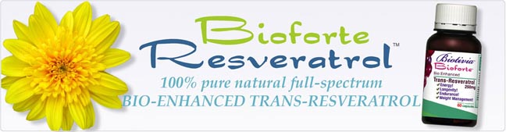
James Betz, founder and CEO of Biotivia, made this announcement to show his appreciation for the armed forces personnel who are serving abroad.
"I have served in the US Army myself and I understand the demands placed upon our armed forces. Not just to be in combat, but also to be away from friends and family in a hostile environment. All of this can have a negative effect on a person's health, so if any of the Resveratrol enhanced natural herbal products we make can benefit serving personnel, I'm very happy to support them."
As a former Captain in the 1st Special Forces Group, Betz knows first hand what these servicemen and women have to go through. He says, "Physical and mental well-being is high on each individual's priorities, and Biotivia's unique range of Resveratrol-based supplements were designed to help people from all walks of life perform at a high level."
Betz continues: "Soldiers are strong proponents of fitness and advanced nutrition. Resveratrol and our co-ingedients helps men and women to increase physical and mental energy, improve strength and endurance, and fight aging. These are important qualities for the modern soldier.
To qualify for the discount, orders need to be dispatched to an official Armed Forces AFO or APO address. Simply insert the code 'AFPO' into the discount panel shown on the shopping cart at http://www.biotivia.com
A copy of the coupon is on Biotivia's Facebook page:
http://www.facebook.com/pages/Biotivia/148780981992
A copy of the coupon is on Biotivia's website:
http://www.biotivia.com/company/afpo.html
About James Betz and Biotivia:
James Betz is a former Army Captain who served in Vietnam and Japan. He was in the army for 6 years and served in various overseas deployments. After leaving the army he became a Ph.D candidate in Cell Biology and has studied life extension and nutrition sciences for over 27 years, including 5 years working with the indigenous tribes on Pacific ocean islands.
He has advised leading European and US functional food producers on enhancing of their products with polyphenols and probiotics.
James is currently assisting researchers at several universities in the US and Europe on the design and implementation of human trials for Resveratrol's medical and health applications.
Biotivia was established nearly 20 years ago and has since grown into one of the world's most respected bioceutical companies. A specialist in science-based supplements with clear health properties, Biotivia is a market leader in the research and development of all-natural herbal remedies and prides itself on sourcing the most effective ingredients with the highest potency levels.
Learn more about Biotivia, the leading Resveratrol specialist bioceutical company, athttp://www.biotivia.com
Download the Armed Forces voucher at http://www.biotivia.com/company/afpo.html
See independent videos about Resveratrol at http://www.biotivia.com/youtube.html
See Biotivia's Facebook page at http://www.facebook.com/pages/Biotivia/148780981992
Contact Details: Biotivia Bioceuticals LLC
1 River Place, Suite 1001
New York, NY 10036
Tel: +1-888-245-5893
Email: roger.day@biotivia.com

~~~~~

Press release distributed via EPR Network (http://express-press-release.net/submit-press-release.php)

