Cloggs Predicts Massive Fitflops Sell Out This Spring


Released on: February 11, 2010, 2:53 am
Author: Cloggs
Industry: Retail
Cloggs has started packing its warehouse with the Spring/Summer collection of Fitflops.
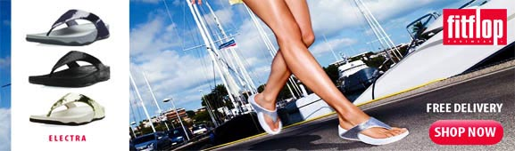
Since 2008, Fitflops have proved to be a massive hit in the UK, with everyone clamouring to get hold of a pair so that they can get a Workout While They Walk. This trend is set to continue throughout Spring 2010, and whilst official Fitflops retailers like Cloggs.co.uk are packing out their warehouses with all the top styles in all the latest colours in an effort to satisfy demand, sales are still set to soar and outstrip supply.
Fitflops have become an iconic fitness footwear brand and a massive fashion trend, ever since being endorsed by Opera Winfrey on her show in 2008. Loved by celebrities including Mischa Barton, Hilary Swank and Marcia Cross, Fitflop fever has spread throughout the UK like wildfire.
People across the world are reaping the fitness benefits from this shoe with the gym built in, which has actually been biomechanically engineered to give the wearer a workout while they walk. The unique Microwobbleboard technology that has been inbuilt into the sole actually destabilises the foot making the muscles in the lower body work harder. Wearers burn more calories than they would do walking normally, and posture is improved too.
With all of these benefits, Fitflops have proved to be a phenomenal success. So much so that Fitlops have introduced a massive new colour range of mens Fitflops and womens Fitflops for Spring and Summer 2010 including the Electra in delicious pewter, the new red Fitflop Walkstar and Fitflop sandals like the Oasis in grey. Official retailers like Cloggs are buying as much stock as they can physically get hold of to satisfy consumer demand, but it is forecast that Fitflops will sell out very quickly.
Nick Thomas, Cloggs.co.uk director, stated: "Fitflops sales have always outstripped our expectations, the demand is absolutely massive. We have always tried to buy as much stock as we can, but demand is consistently outstripping the manufacturing runs. The new Spring/Summer 2010 styles have just come into stock but as soon as we are uploading them onto our website they are flying out again. We do advise eager customers to start thinking about their Spring/Summer Fitflop footwear now to avoid disappointment."
Used by many as a great an alternative to a pricey gym membership, Fitflops are the ideal footwear equipment to increase fitness and well-being by simply wearing whilst going about everyday activities.
About Cloggs:
Cloggs.co.uk is very proud to be authorised retailers of the famous Fitflops brand. With more than 35 years of trading experience, Cloggs has long been at the forefront of cutting edge British shoe retail. With a focus on in season fashion footwear, quality customer service, competitive prices and extensive selection, Cloggs.co.uk stocks over 20,000 items including its popular range of UGG boots, Converse trainers, Crocs, Dr Martens and Timberland boots.
Cloggs PR contact:
Tricia Williams
Online Marketing Manager
110 – 114 Corporation Street
Birmingham
West Midlands
B4 6SX
Tel: 0121 237 5528
www.cloggs.co.uk
~~~~~

Press release distributed via EPR Network (http://express-press-release.net/submit-press-release.php)

