Estee Lauder Introduces Michael Kors Collection


Released on: February 04, 2010, 10:11 am
Author: Estee Lauder
Industry: Retail
Estee Lauder proudly introduces the Estee Lauder Michael Kors Very Hollywood Color Collection. This collaboration stemmed from the longtime friendship between Aerin Lauder, Estee Lauder senior vice president and creative director, and acclaimed American designer Michael Kors.
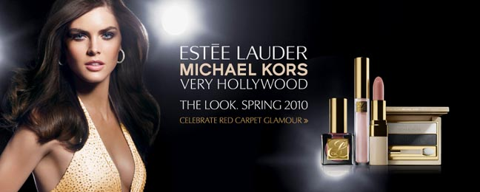
Michael Kors said: "Nobody understands modern glamour and luxury like Aerin Lauder and the Estee Lauder brand, which is what this collection is all about." said Michael Kors.
The Estee Lauder Michael Kors Very Hollywood Color Collection is a group of limited edition, limited distribution products, which reflect both the timeless beauty philosophy of Estee Lauder and the luxurious, modern fashion style of Michael Kors.
The Estee Lauder Michael Kors Very Hollywood Color Collection features two modern-classic looks.
Bel Air Beige showcases a classic Michael Kors beige and coral palette of shimmery peach lips and cheeks and a smokey eye, while Rodeo Pink spotlights new shades in vibrant raspberry tones of bright, bold lips and cheeks and a defined eye.
Both colour palettes contain the essentials needed to achieve the Very Hollywood look of choice and feature coordinating shades of blush, eye shadow duo, eye pencil, Lip Sheen SPF 15, lip gloss and nail lacquer.
In the colour collection's advertising shot, Estee Lauder model Hilary Rhoda appears in a striking photograph shot by Craig McDean. Her sparkling gold Michael Kors gown reflects the flashes from the paparazzi cameras as she steps on to the red carpet.
The Estee Lauder Michael Kors Very Hollywood Color Collection is available to purchase in a limited number of stores around the country. However, it can also be purchased from the Estee Lauder website and delivered to the customer via any one of five delivery options, including next day delivery.
Michael Kors said: "Hollywood is the birthplace of fantasy and dreams. The inspiration for the Estee Lauder Michael Kors Very Hollywood Color Collection is iconic Hollywood glamour, both past and present, interpreted for everyday life."
About Estee Lauder
In 1946, Estee Lauder started business with one face crème, and the desire to bring out the beauty in every woman. By the time the revolutionary fragrance Youth-Dew was introduced in 1953, the Estee Lauder Company had already won a reputation for innovation, research and quality.
Now Estee Lauder's skincare, makeup and fragrance collections exemplify the best that technology, science and arts can achieve. The Estee Lauder name on a product is recognised in over 100 countries for quality and has gained a worldwide reputation for elegant, and luxurious products that uphold the finest standards of excellence through extensive research and stringent product testing.
The Estee Lauder Companies' annual Breast Cancer Awareness Campaign involves all of the 18 brands that make up The Estee Lauder Companies. They collectively represent The Breast Cancer Research Foundation's first and largest corporate supporter. Estee's daughter-in-law was the creator of BCRF's signature pink ribbon. Over $10 million has been raised for The Breast Cancer Research Foundation since 1993. Another $1 million was raised from their retail partners since July 2002.
For more information please contact:
Brona McCafferty
Communications Coordinator
73-75 Grosvenor Street
London
W1K 3BQ
0870 034 6823
www.esteelauder.co.uk

~~~~~

Press release distributed via EPR Network (http://express-press-release.net/submit-press-release.php)

