Hazmat Training Comes to Nashville


Released on: February 16, 2010, 3:44 am
Author: Environmental Resource Center
Industry: Environment
February 16, 2010- When workers handle hazardous waste or ship hazardous materials, training is not just a good idea, it’s the law. According to the EPA, workers who handle hazardous waste must be trained annually, and the federal DOT requires that workers involved in the shipment of hazardous materials be trained at least every three years.
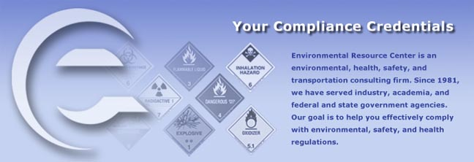
Environmental Resource Center, the leading provider of environmental and safety training, will present the mandatory training in Nashville on March 2-4, 2010 at the Radisson Hotel, Nashville Airport. Classes begin at 8am and end at 5pm each day.
Hazardous Waste Management: The Complete Course will be taught on March 2 and 3.
DOT Hazardous Materials Training: The Complete Course will be taught on March 4 at the same location.
Registration for the training is available by calling 800-537-2372 or at http://www.ercweb.com/classes.
Now in its 29th year, Environmental Resource Center trains not only thousands of industry personnel every year, the company also trains personnel from most of the state and federal agencies that enforce the regulations.
Contact Details: Malia Campbell
Environmental Resource Center
919-469-1585; Fax: 919-342-0807
mcampbell@ercweb.com
http://www.ercweb.com
~~~~~

Press release distributed via EPR Network (http://express-press-release.net/submit-press-release.php)

