Snip-its Kids Salon Franchise Presents Unique Opportunity for New Entrepreneurs


Released on: February 04, 2010, 5:31 am
Author: Snip-its
Industry: Retail
Entrepreneur Magazine Top 500 Franchise is SBA-registered, ideal for new business owners
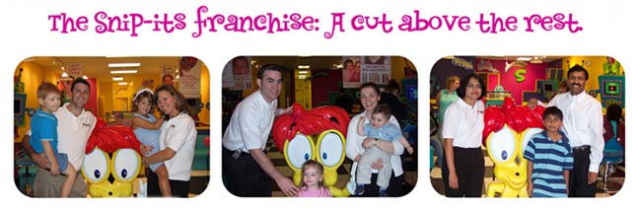
NATICK, MASS. (February 2010) -- As part of an aggressive growth strategy, the children’s hair salon Snip-its (www.snipits.com) is seeking franchisees to open new stores throughout the U.S. Snip-its, already the nation’s fastest growing children’s salon franchise with currently 65 stores in 26 states, will partner with new entrepreneurs and business owners to capture even more of the expanding children’s hair care market.
Hair care generates an estimated $45 billion annually and is considered a non-cyclical industry - the demand for haircuts, as with goods like utilities and household products is constant and not greatly affected by dips in the economy; a salon business is considered ‘recession-proof’. There are 40 million children in the US, who on average will have their hair cut eight times every year. Within the hair care industry, children’s hair care is the fastest-growing sector, accounting for $5 billion annually.
Franchise businesses are especially appealing in times of high unemployment and slow economic growth. They represent an opportunity for great profits, but with lower risk, owing to the power of an established, loyalty-driven brand, proven industry expertise, and the broad reach of national advertising.
Requiring no previous hair care or cosmetology experience, the Snip-its franchise is ideal for new and first-time business owners. “In fact, we prefer management, general business, or marketing experience to hair care experience,” says Christine Mudd, director of franchise development at Snip-its. ”A passion for the brand, commitment to excellence, desire to succeed, and willingness to learn are all you need. Snip-its provides its franchisees with a proven operating model and business tools to help them succeed.”
The Snip-its brand is unique within the hair care industry. Sporting a distinctive interior design featuring the company’s own cartoon characters and video game stations, Snip-its salons offer a wide range of fun, kid-friendly hair cutting and styling services, spa-style treatments for girls, and a full-line of exclusive hair care products, while also hosting parties and special events.
A visit to Snip-its is a full-on entertainment experience that’s been proven to inspire strong loyalty - over 65% of the company’s customers return every six to eight weeks. “We're turning what can sometimes be a challenging experience into a fun-filled, entertaining, family adventure," continued Mudd. "The result is a hair salon no kid can resist and a business model enticing to prospective franchisees."
For more information on Snip-its franchising, please visit:
http://snipits.com/franchising/franchise_faq.cfm.
About Snip-Its
The Snip-its Corporation, based in Natick, Massachusetts is designed to untangle the hair care challenges of children and their parents. It provides the best customer service and a guaranteed great time for both kids and parents. The women owned franchise has served more than one million children annually in 65 locations. In 2007, Snip-its was named the 30th fastest growing franchise in the U.S. by Franchise Times Magazine. For more information on children’s franchise opportunities, visit www.snipits.com or call 877-SNIP-ITS.
###
Contact Details: Christine Mudd
Christine@frandeavor.com
949-498-2611
http://www.snipits.com
~~~~~

Press release distributed via EPR Network (http://express-press-release.net/submit-press-release.php)

