Weight Loss – A Healthier Lifestyle from Healthsurvey.org


Released on: February 24, 2010, 10:26 am
Author: HS Weight Loss LLC
Industry: Healthcare
Through http://www.healthsurvey.org learn the fundamentals of weight loss, through our dedicated programs of weight reduction. Obese and over weight individuals face numerous problems in life, which can be combated with knowledge of weight loss decreasing methods, in a healthy way. Contrary to common belief, the real causes of obesity include bad nutrition, stress, emotional issues and hormonal imbalance and of course lack of mobility. Obesity contributes to the risk of diabetes, paralysis, possible cardiac arrest and other fatal complications.
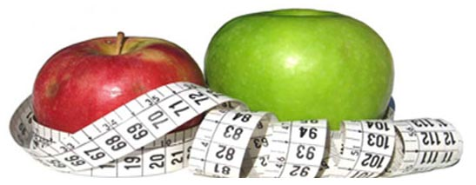
Despite all the attention this particular topic receives, obesity rates keep escalating due to fast food, unhealthy ready to make meals, fizzy drinks combined with reluctance to exercise. If an individual is serious about losing weight, this way of life has got to change. Making extreme changes by sudden diets and over exertion through rigorous exercise regimes is not the solution. Weight loss requires a change in diet paired with increased activity.
Cut back on calories by finding alternatives to your regular diet. Instead of frying, food can be cooked by grilling, boiling or steaming. Make sure you use a vegetable oil like olive, soya bean or canola. Increase the amount of vegetables and fruits, high in vitamins, in your healthy diet. Try leaner less fatty meat options like chicken, sea food and turkey. Lentils and beans are an excellent source of protein. Replace regular bread with brown or whole wheat. Eat less fast foods and packet foods, opting rather for healthier snacks like granola bars or nuts and dry fruit. Go easy on dessert, remember moderation is the key.
Say no to fizzy drinks, canned or bottled juices and energy drinks. Instead fresh fruit juices will provide healthier levels of glucose which are stored after hours (though the energy from fruit juices is usually used up before that occurs), unlike sugary juices which store in the body after 20-30 minutes of consumption. Drink lots of water to ensure the body receives an adequate amount of fluids, 16 glasses a day will do fine. Find weight loss centers in your city.
Increase activity, if not by regular exercise, then a 3-5km walk or jog, individual or team sports or even riding a bike. Light exercise or aerobics is desirable though, if not initially then in time.
Try eliminating fatty products from your shopping list. Instead opt for healthier substitutes.
People who are obese are prone to risks which range from; hypertension, respiratory problems, psychological disorders, arthritis, strokes, diabetes and much more. Choose a healthier lifestyle through Healthsurvey.org, by changing you way of life. When a better looking, more active and better you appears physically and mentally rejuvenated, you'll thank us for expertise. See also Weight Loss Programs|Weight Loss Techniques|
Contact Details:
HS Weight Loss LLC World Trade Center Delaware
702 West Street, Suite 100
United States: Oklahoma,Catoosa 19801
tel: +1 (302) 353-4577
fax: +1 (302) 397-2092
topmed1@ya.ru
~~~~~

Press release distributed via EPR Network (http://express-press-release.net/submit-press-release.php)

