World Renowned Drug Abuse Treatment Center in California
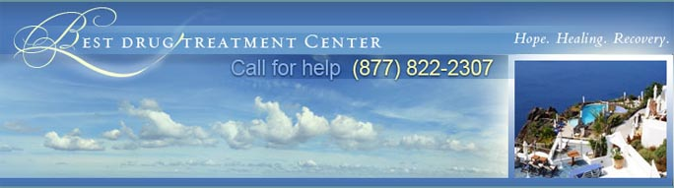

Released on: February 19, 2010, 8:05 am
Author: bestdrugtreatmentcenter.com
Industry: Healthcare
The best drug abuse treatment center is the one that cares most deeply about its individual clients. Drug addiction is a personal problem, and drug treatment must be a personal process. If you're going to get sober, it's going to be on your own terms, in a way that's meaningful to you and no one else. The drug abuse treatment center that's right for you is the one that can help you do exactly that.

There are plenty of drug treatment centers in Los Angeles. Unfortunately, they aren't all equally committed to meeting the individual needs of their individual residents. On the contrary, many of the most "exclusive" drug abuse treatment centers in California offer the same generic drug treatment programs to every patient who seeks their help. As should go without saying, these institutions can't be trusted to produce meaningful or lasting drug recovery.
The good news here is that the best drug treatment center in Malibu is different. The exclusive drug abuse treatment center uses specialized programs designed on a case-by-case basis, with the explicit goal of helping clients heal from the inside-out. That patient-centered approach helps to explain why the center's residents enjoy such a robust rate of success. It should also leave no doubt as to where your interests will be best be served. Successful drug treatment will quite literally change your life. Here's hoping you'll be wise enough to learn that truth for yourself.
BestDrugTreatmentCenter.com provides information on one of the best drug treatmentfacilities in the world, where treatment programs involve individual privacy, luxury and a unique drug treatment therapy plan. If you'd like more information about finding the bestdrug treatment center for you, please call 1-877-822-2307, visit our website athttp://www.bestdrugtreatmentcenter.com/, or contact us at admissions@bestdrugtreatmentcenter.com.
This press release may be used freely, provided that the resource box is included and the links are active. A courtesy copy of the issue or a link to any online posting would be greatly appreciated.
Contact Details:
http://www.bestdrugtreatmentcenter.com/
admissions@bestdrugtreatmentcenter.com
1-877-822-2307
Malibu, CA 90265
~~~~~

Press release distributed via EPR Network (http://express-press-release.net/submit-press-release.php)

