French Connection Launches Exclusive New Kick Ass Collection


Released on: March 24, 2010, 10:00 pm
Author: French Connection
Industry: Retail
French Connection launches exclusive range of tees and sweats to celebrate the hotly anticipated 2010 superhero action movie Kick Ass.
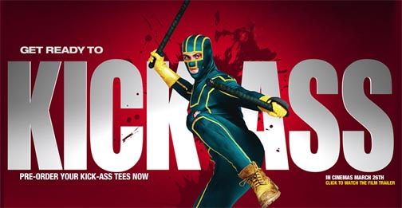
The new film includes Executive Producer credits for French Connection UK Chairman and CEO, Stephen Marks, and has been adapted from Mark Millar’s best-selling comic book series of the same name.
Kick Ass tells the story of an average teenager who is inspired by his favourite comic books and decides to become a real-life superhero himself. However, the self-titled ‘Kick-Ass’ is devoid of one important thing… superpowers.
Young Brit star Aaron Johnson plays the lead role of Dave Lizewski/ Kick-Ass, but no superhero is complete without a sidekick. Nicholas Cage (a.k.a. Big Daddy) plays a former cop who, in his quest to bring down an evil drug lord, has trained his 11-year-old daughter to be a ruthless sword-wielding vigilante Hit Girl.
The film's script was written by Matthew Vaughn and Jane Goldman, who previously wrote the smash hit Stardust together. Vaughn directed the film, and produced it with Brad Pitt (among others), cementing its Hollywood cool credentials.
The film's superhero costumes strike just the right balance between looking ridiculous and kind of cool - they are accessible enough for even non-superheroes to aspire to trying this at least once for themselves. But for those not brave enough to venture out in a head-to-toe suit; French Connection has launched its new Kick Ass collection that features a number of men's t-shirts to provide the next best thing.
Stephen Marks wanted the exclusive new range to build on French Connection's already firmly established collections of retro film inspired apparel with an exclusive set of Kick Ass t-shirts and sweats. Tops come in dark and sinister black and greys, or alter-egos can shine in Kick Ass' signature colours of jade and yellow. Featuring iconic empowering catchphrases, film logos, and original comic book illustrations, now anyone can show their allegiance to all that is good and right in the world of style by wearing one of French Connection's superhero t-shirts.
About French Connection
French Connection was founded in 1972 by Stephen Marks who set out to create well-designed womens clothes that would appeal to a wide audience. French Connection now offers a fashion-forward clothing range, including full men's clothing collections, with a quirky spin on design, priding itself on quality and affordable prices.
Having established a strong core clothing business, through design and an idiosyncratic sense of style, French Connection has recently expanded its portfolio into exciting new areas including men's and women's toiletries, sunglasses, watches and shoes.
Driven by innovation and change, the brand's strength lies in mixing new ideas with the basic promise of quality and affordability, established more than 30 years ago when the business was founded. Throughout this expansion and diversification the principles have remained the same; design-led products presented in a unique and innovative way.
For more information, images, or samples – please contact:
Tobie Lewis
French Connection
Centro One
39 Camden Street
London
NW1 ODX
0207 036 7212
www.frenchconnection.com
~~~~~

Press release distributed via EPR Network (http://express-press-release.net/submit-press-release.php)

