Hazmat Training Comes to Charleston


Released on: March 22, 2010, 12:10 am
Author: Environmental Resource Center
Industry: Environment
March 22, 2010 – When workers handle hazardous waste or ship hazardous materials, training is not just a good idea, it’s the law. According to the EPA, workers who handle hazardous waste must be trained annually, and the federal DOT requires that workers involved in the shipment of hazardous materials be trained at least every three years.
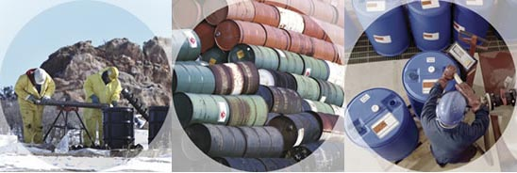
Environmental Resource Center, the leading provider of environmental and safety training, will present the mandatory training in Charleston at the Hilton Garden Inn - Charleston Airport on March 30 – April 1, 2010. Classes begin at 8am and end at 5pm each day.
Hazardous Waste Management: The Complete Course will be taught on March 30 and 31.
DOT Hazardous Materials Training: The Complete Course will be taught on April 1 at the same location.
Registration for the mandatory training is available by calling 919-469-1585 or at http://www.ercweb.com/classes
Now in its 29th year, Environmental Resource Center trains not only thousands of industry personnel every year, the company also trains personnel from most of the State and Federal agencies that enforce the regulations.
Contact Details: Malia Campbell
Environmental Resource Center
101Center Pointe Dr.
Cary, NC 27513
919-469-1585; Fax: 919-342-0807
mcampbell@ercweb.com
http://www.ercweb.com
~~~~~

Press release distributed via EPR Network (http://express-press-release.net/submit-press-release.php)

