Recovering the Industry, Spa Covers by The Spa Bra™


Released on: March 11, 2010, 3:47 am
Author: Mary James
Industry: Retail
The Spa Bra is not the top half of an itsy-bitsy teenie-weenie yellow polka dot bikini. Nor is it the latest fashion craze for lounging around the spa. In fact, it’s not an apparel item at all. But brace yourself, because it just might be the next big thing to sweep through your neighborhood.
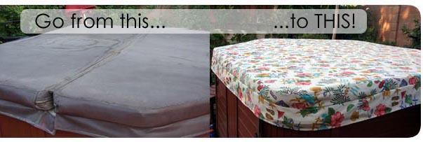
The concept of The Spa Bra™ was conceived as Arizona native Mary James started to see the damage that her own hard spa cover was sustaining under the blazing Arizona sun. With her spa strategically placed in the center of her well manicured yard among flowers and plush landscaping, she worried that her spa would become an eyesore in the midst of the serene atmosphere she had worked so hard to create.
Necessity is truly the Mother of Invention and The Spa Bra™ became a reality. Ms. James realized that spa owners around the world have a similar need to protect their spa investment by protecting their expensive hard spa cover from the damage by the sun, wind, rain, ice and various environmental elements.
The Spa Bra™, ecommerce (www.thespabra.com) grand opening was launched in 2008 and is being featured in several spa stores in the Valley. New products have been introduced, including The Spa Bra™, The Spa Bra™ With a Lift, The Spa Bra™ Hard Vinyl Support Cover, The Bar-B-Bra Grill Cover and The Spa Bra™ First Edition.
The Spa Bra™ is made of waterproof, sun resistant outdoor material and hugs the hard spa cover to protect it and increases its longevity. Even if a cover is already damaged, The Spa Bra™ restores its appearance and defers the necessity of replacing another expensive hard cover. New cover owners love knowing that their expensive hard covers are being protected for years. The Spa Bra™ can be used for spa covers of many geometric sizes, shapes or forms and is available in a wide variety of patterns and solid colors.
The Spa Bra™ First Edition is being acknowledged by Arizona winter visitors as a product that will allow them to close up their spas and not have to worry about the intense Arizona sun damaging their spa covers while they are away during the summer months. The Spa Bra™ First Edition has a heavy duty cinch around the base of the cover to prevent it from blowing away during the Arizona Monsoon season.
The newest product from The Spa Bra™ to be introduced is The Bar-B Bra or Grill Covers in Arizona, by The Spa Bra™, that is designed to protect your grill. The Spa Bra’s, Bar-B-Bra will withstand the test of wind and weather but will also provide a beautiful accent to your outdoor decor. Unlike the thin, black plastic grill cover that becomes destroyed in the wind, the Bar-B-Bra is constructed with a heavy duty cinch at the bottom which will prevent your cover from flying away.

The Spa Bra™ products are custom created, using a wide variety of the most beautiful and vibrant Sunbrella outdoor materials.
The Spa Bra™ Hard Vinyl Covers are custom made of a high grade, heavy duty Marine Vinyl that will stand the test of time. They have been manufactured in the valley for over 25 years.
Covers from The Spa Bra™ are washable and are packaged in a coordinated beach bag.
About Thespabra.com:
Ms. James created and designed The Spa Bra™ with long term use and beauty in mind. When it comes to spa covers, The Spa Bra™ knows how to deliver on excellent customer service and a great product. With so much money invested in your hot tub or grill, spa covers or grill cover is the smartest way to protect that investment. Check out Thespabra.com today or give Ms. James a call at 602-796-2312. The Spa Bra™ enjoys the work that they do and looks forward to changing the Spa Cover Industry.
Contact Details: The Spa Bra
1030 W. Carter Drive
Tempe, Arizona 85282
602-796-2312 Business
480-688-1796 Cell
mary@thespabra.com
www.thespabra.com

~~~~~

Press release distributed via EPR Network (http://express-press-release.net/submit-press-release.php)

