Wallace & Gromit Get Smart With npower On The Small Screen


Released on: March 25, 2010, 12:04 am
Author: npower
Industry: Energy
Fans of Oscar-nominated Wallace and Gromit are to be treated to another dose of the favourite duo as they appear in npower's new TV advert.
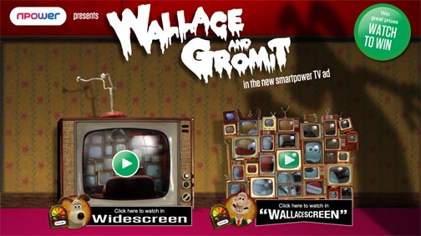
The nation's favourite animated characters are up to their usual 'inventive' mischief in delivering npower's message of sensible energy consumption in the home. The loveable duo soon learns a valuable lesson in monitoring energy, as another invention goes wrong.
The new advertising campaign created by VCCP for npower is in a 30 and a 40 second format and breaks on 29 March until 7 May on ITV (Mid West & North) and Channel 4.
The 30 second advert opens in a darkened room where Wallace is in a state of panic. Hidden behind a cushion he watches a horror movie on his latest invention, a homemade widescreen TV. Wallace's widescreen TV defies convention, consisting of multiple TV's taped together.
However, a scary movie is not the only thing poor Wallace has to worry about when the penny finally drops that his pile of TV's has in fact become an energy consuming monster.
Luckily, the savvier Gromit saves the day when he receives advice from customer care advisor Penny on how to cut energy consumption.
Our heroine informs Gromit about the npower smartpower electricity monitor, which allows customers to keep an eye on how much energy is being eaten up by all household appliances.
The 40 second advert actually shows the viewers what movie is scaring the life out of Wallace - Revenge of the Killer Watts - as well as having an additional scene of Gromit creeping up on Wallace and passing family photographs of Frankenwallace and Dracuwallace along the way. The end of the advert cuts straight back to the ominous pile of televisions 'sparking' to life.
The new Wallace & Gromit advert is part of the energy supplier's smartpower campaign to help customers monitor and reduce energy consumption in the home with the offer of free smartpower electricity monitors when existing and new customers sign up to an online account.
Kevin Peake, marketing director at npower, commented: "We're all guilty of being like Wallace and Gromit and wasting too much energy in the home, but we want to show that there are ways where we can help our customers save energy and money.
"smartpower electricity monitors are a great tool for customers to quantify how they use energy in the home and Aardman's Wallace & Gromit really bring this message to life."
The advert is part of an exclusive npower series of animations created by Nick Park's Aardman Animations and VCCP.
Sean Clarke, Head of Aardman Rights said: "Wallace and Gromit lend themselves perfectly to dispelling the myths around energy efficiency in the entertaining way they are famous for."
About npower:
npower has 6.6 million residential gas and electricity accounts throughout the UK. npower is a market leader in renewable energy. npower juice matches green energy primarily from off-shore wind farms for juice customers at no extra cost. Customers can join the energy industry discussion on npower's interactive debating website the brighter energy debate where they can post their questions, views and comments.
For further information, interviews and images please contact:
Ben Dobson
Resonate
5th Floor
Holborn Gate
330 High Holborn
London
WC1V 7QG
020 7861 2525
~~~~~

Press release distributed via EPR Network (http://express-press-release.net/submit-press-release.php)

