npower Pledges To Continue Boiler Scrappage Scheme
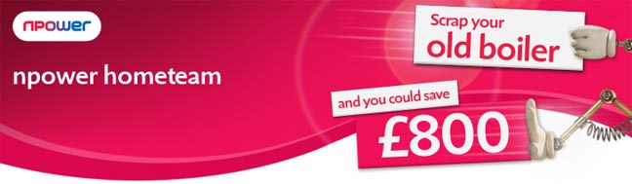

Released on: March 26, 2010, 9:22 am
Author: npower
Industry: Energy
npower has become the first energy supplier to pledge to continue its boiler scrappage scheme once the Government scheme closes.
The Government’s boiler scrappage scheme launched in January and in the first six weeks alone, over 50,000 households benefited from the initiative*, from a total allocation of 125,000.
npower became the first energy supplier to launch its own boiler scrappage scheme when it promised to match the Government’s £400 grant. The combination of the two scrappage schemes means customers could be eligible to receive as much as £800 towards the cost of a new boiler, when replacing a G rated boiler with an energy efficient A rated boiler.
Kevin Miles, CEO npower retail, said: "The scrappage scheme has proven to be extremely popular and if take-up continues at the same rate, we expect the Government’s scheme to close in April. However, there are still approximately four million households with G-Rated boilers in the UK, which is why we are pledging to continue npower’s boiler scrappage scheme."
npower’s scheme differs from the Government’s scheme in that customers only have to have a boiler that is over 10 years old to be eligible to receive a £400 discount on a new boiler installation from npower hometeam.
In addition to the discount, the hometeam installation service includes SEDBUK A rated energy efficient boilers and a free warranty of up to five years on all Valiant boilers, with a 10 year warranty on radiators.
-ENDS-
Notes to editors:
* Source: The Energy Savings Trust
About npower
npower has 6.6 million residential gas and electricity accounts throughout the UK. npower is a market leader in renewable energy. Consumers can join the energy industry discussion on npower's interactive debating website - the brighter energy debate, where they can post their questions, views and comments.
npower is also dedicated to helping UK businesses use energy more efficiently and therefore spend less money on their bills. It aims to have a positive impact on the communities it serves and reduce customers' carbon footprints whilst always improving service.
npower hometeam installs, and provides boiler servicing, in addition to offering gas boiler repair and a wide variety of heating cover options in conjunction with homeserve.
-ENDS-
For media information please contact the npower press office:
Nick McHugh
Press and Public Relations
npower
Oak House
Bridgwater Road
Worcester
WR4 9FP
0845 070 2807
www.npower.com
~~~~~

Press release distributed via EPR Network (http://express-press-release.net/submit-press-release.php)

