BabyShowerStuff.com Debuts Newly Redesigned Web Experience
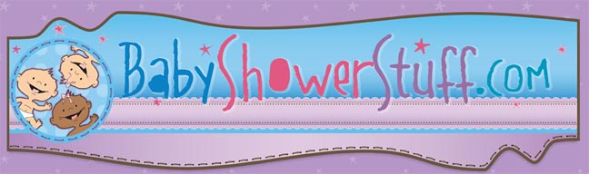

Released on: April 20, 2010, 10:05 pm
Author: BabyShowerStuff.com
Industry: Retail
Newly designed web site features easier navigation, while Twitter and Facebook pages provide the latest information on baby shower trends
MENOMONIE, Wis., April 2010 -- BabyShowerStuff.com, the ultimate online retailer of baby shower favors, baby shower invitations, and accessories has announced the launch of their newly redesigned website. The new site facilitates an easy and fun shopping experience for moms-to-be and baby shower party planners. Along with the new design the company has also entered the sphere of social media, having launched Twitter and Facebook pages to open up a whole new world of customer interactivity.
The new BabyShowerStuff.com online store features an expanded categories list that enables customers to easily locate the exact items needed to plan the perfect shower. “Our new design for BabyShowerStuff.com is a fun whimsical place for our customers to shop,” explains Sherri Yukel, founder, BigDotOfHappiness.com. “We wanted to create the ultimate one-stop baby shower shopping experience for our customers.”
The retailer is proud to feature a huge line of exclusive original baby shower themes andbaby shower favors, created in-house by its own expert design team. Their latest creations include the adorable “Owl-Look Whooo’s Have A Baby” and “Baby Elephant” themes.
In keeping with its commitment to customer service, the retailer has launched Twitter and Facebook pages to communicate the latest updates regarding the company’s site, showcase the hottest new items, and allow customers to interact with the company, and with fellow baby shower planners and fans of BabyShowerStuff.com.
“Our mission is to help moms and party planners create fun, trendy baby showers, and now Twitter and Facebook have enabled us to interact with our customers in a whole new way,” says Yukel. “Our Twitter is updated frequently and we’re sending out tweets about the latest products, party planning ideas straight from the minds of our baby shower expert experts, and exclusive discounts on our site. We love the Facebook since it allows customers to share with us photos and stories from their own baby shower events.”
About BabyShowerStuff.com
The Baby Shower Event Specialty Site, BabyShowerStuff.com is a company run by fanatics who personalize favors, invitations, games, banners and gifts. The company, which is a division of BigDotOfHappiness.com, features exclusive original baby shower games, baby shower tableware, baby shower decorations and more, and employs “expert experts” to guide and assist customers all the way to the perfect baby shower and help them become party planning heroes.
About BigDotofHappiness.com
BigDotofHappiness.com began as a hobby in the living room of its founder, Sherri Yukel. Today, the site provides all the imaginable party and event items under one roof. BigDotofHappiness.com is the premier event party company specializing in baby showers, bridal showers, wedding showers, bachelorette parties, birthday parties, party invitations and party favors. Thanks to its creative staff, BigDotofHappiness.com is the originator of unique games, invitations and themed party supply products known as "Big Dot Originals."
# # #
Contact Details: Brenda Knutson, Manager
Big Dot of Happiness
800.274.4282
Smiles@BabyShowerStuff.com
~~~~~

Press release distributed via EPR Network (http://express-press-release.net/submit-press-release.php)

