GQ Unveils The GQ Citroën Concept Car


Released on: April 07, 2010, 10:11 pm
Author: GQ
Industry: Automotive
GQ has created made to measure suits, personalised aftershaves, handmade shoes and limited-edition accessories, it has given its name to racehorses, bars and houses. So it was only a matter of time before GQ took its penchant for the bespoke to its logical conclusion: its very own concept car. Working with French automotive design legends Citroën, and with a smattering of Savile Row magic, GQ presents the GQ Citroën concept car.
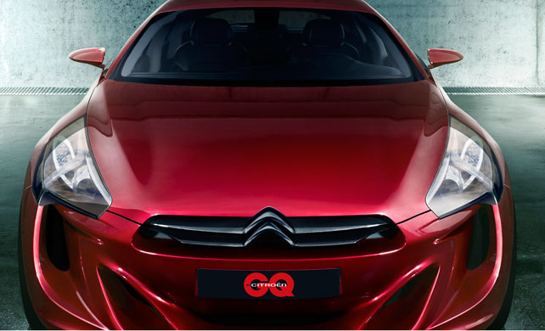
Dylan Jones, Editor of GQ, commented, "I wanted something practical, something cool and something idiosyncratic. The GQ car needed to have the "want" factor, but it also needed to look, feel and "drive" like the sort of car no sane man could ignore. We think it looks very, very special."
Having taken a brief from Dylan Jones, Citroën's team, lead by British designer Mark Lloyd, took a GT body style and blended it with classic Citroën detailing. Combining classically sophisticated features and contemporary styling with a sculpted front end, rounded rear, strong body contours and sleek concave rear windscreen - a signature Citroën design.
The minimalist interior detailing and upholstery was provided by Patrick Grant, the Creative Director of Savile Row tailors, E. Tautz. The car's cabin is accessed by rear coach doors, opening to reveal a spacious, comfortable and futuristic cabin.
Dynamic performance and environmental responsibility were also key requirements for this project. The car is powered by a plug-in Hybrid with a 1,598 cc, 4-cylinder direct injection petrol engine offering a sporty 0-60mph in a time of just 4.5 seconds, an electronically limited top speed of 155 mph and CO2 emissions of just 80g/km.
Mark Lloyd, Chief Designer of Citroën's International Projects added, "Where this car works so well with GQ is that it fits with the current attitudes of conspicuous consumption. It is understated rather than in-your-face, sleek rather than macho. With the skill of a Savile Row tailor on the car's interior we have achieved that bespoke, fitted feel, both inside and out."
Domagoj Stefan Dukec, Citroën's Design Supervisor, commented; "For me, the car that has always represented the pinnacle of automotive excellence and refinement is the GT - the Grand Tourer. It is not the all-out sports car, rather it is something gentlemanly, it has performance and it is for travelling, not racing. We wanted to create something that, like GQ, was aspirational, but also retained the classic automotive ideals. We didn't want a car for the mass market. We wanted a car for GQ."
The GQ Citroen concept car is featured in the April issue of British GQ, and car was revealed in the "flesh" on the 4th March at a private event in central London.
About GQ:
GQ is the UK's biggest selling quality men's magazine. Part of the Condé Nast stable - who also publish titles Vogue, Wired, Glamour and Vanity Fair - GQ regularly features original journalism from writers including AA Gill, Will Self, Tony Parsons, Rod Liddle, Alexis Petridis, Piers Morgan, Matthew d'Ancona and Tom Parker-Bowles. The magazine is recognised as the authority on men's style and men's fashion, and also works with the best photographers operating today including David Bailey, Sam Taylor Wood, Simon Emmett, and Gavin Bond. GQ's current ABC is 120,057 (July-December 2009).
For further information please contact:
Nicky Eaton
Director of Press & PR - Condé Nast UK & International
Vogue House
1 Hanover Square
London
W1S 1JU
0207 152 3377
www.condenast.co.uk
~~~~~

Press release distributed via EPR Network (http://express-press-release.net/submit-press-release.php)

