Hazmat Training Comes to Philadelphia


Released on: April 10, 2010, 12:02 am
Author: Environmental Resource Center
Industry: Environment
April 10, 2010 - When workers handle hazardous waste or ship hazardous materials, training is not just a good idea, it’s the law. According to the EPA, workers who handle hazardous waste must be trained annually, and the federal DOT requires that workers involved in the shipment of hazardous materials be trained at least every three years.
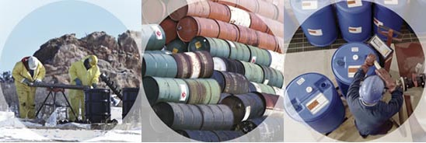
Environmental Resource Center, the leading provider of environmental and safety training, will present the mandatory training in Philadelphia at the Embassy Suites– Philadelphia Airport on April 27 – 29, 2010
Hazardous Waste Management: The Complete Course will be taught on April 27, and 28.
DOT Hazardous Materials Training: The Complete Course will be taught on April 29 at
the same location.
Registration for the training is available by calling 800-537-2372 or at
http://www.ercweb.com/classes.
Now in its 29th year, Environmental Resource Center trains not only thousands of industry personnel every year, the company also trains personnel from most of the state and federal agencies that enforce the regulations.
Contact Details: Malia Campbell
Environmental Resource Center
919-469-1585; Fax: 919-342-0807
mcampbell@ercweb.com
http://www.ercweb.com
~~~~~

Press release distributed via EPR Network (http://express-press-release.net/submit-press-release.php)

