JD And K-Swiss Join Forces To Announce New Competition


Released on: April 02, 2010, 12:33 am
Author: JD Sports
Industry: Retail
JD Sports have teamed up with heritage brand and classic American trainer and sportswear manufacturer K-Swiss to offer a trip for two to California in conjunction with its brand new "Have an Awesome Day" campaign.
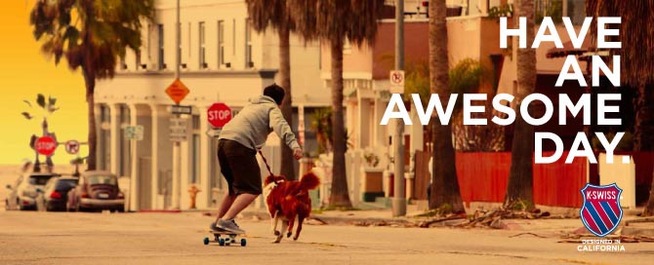
K-Swiss is back on the TV screens with a new style and a big bang in 2010. This year sees the brand taking itself back to the sports-focused California lifestyle that originally inspired the two Swiss brothers who founded K-Swiss to develop the 'Classic', the first ever all leather American tennis shoe. Fuelled by innovative products, brand initiatives, events, celebrities and powerful marketing, the campaign is all about celebrating the California attitude to sports.
To celebrate the re-launch of the 'Classic' at JD and the re-birth of K-Swiss as the California Sports company, K-Swiss have teamed up with JD to offer one lucky customer the chance to win a prize of one week's holiday for two people to sun drenched California. The winners will experience the K-Swiss California Spirit and attitude to sport firsthand, as well as having the opportunity to visit a range of locations including Venice Beach, Santa Monica Beach and Pier, Long Beach and Hollywood Boulevard, of which are featured in the brand new TV campaign dubbed "Have an Awesome Day".
Those wishing to enter the competition can register on the JD Sports website. The competition closes on 31st May
About JD Sports:
JD Sports Fashion Plc is the leading UK specialised multiple retailer of fashionable branded and own brand sports and casual wear. The company operates over 350 stores through the UK.
JD Sports was founded in 1981 with one shop in Bury. It expanded into the Arndale Centre in Manchester in 1983 and consolidated its position throughout the 1980s with further openings, largely in the North and Midlands. The first London store was opened in Oxford Street in 1989 and by the time of JD Sports' stock market flotation in 1996 there were 56 stores.
The business continued to grow organically until 2002 and then grew further with the acquisition of more than 200 stores, further consolidating its position as the leading UK retailer of fashionable sports and casual wear.
As well as offering customers leading womens and mens clothing brands such as adidas Originals, Nike, Lacoste, Converse and K-Swiss trainers, JD Sports also stocks 'own-label' brands mckenzie, Carbrini and Brookhaven.
For further information on JD Sports or this press release please contact:
Kim Jones
JD Sports Fashion PLC
Hollinsbrook Way
Bury
BL9 8RR
0161 767 1659
www.jdsports.co.uk
~~~~~

Press release distributed via EPR Network (http://express-press-release.net/submit-press-release.php)

