Kellogg's and M&S Join Forces To Sell The Special K Red Dress
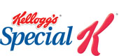

Released on: April 07, 2010, 9:55 pm
Author: Kelloggs
Industry: Retail
Kellogg's has signed a deal with Marks & Spencer to create the first ever Special K red dress to go on sale to the general public.
The dress will be available in M&S stores and online from the end of March and is a unique agreement for both UK brands.
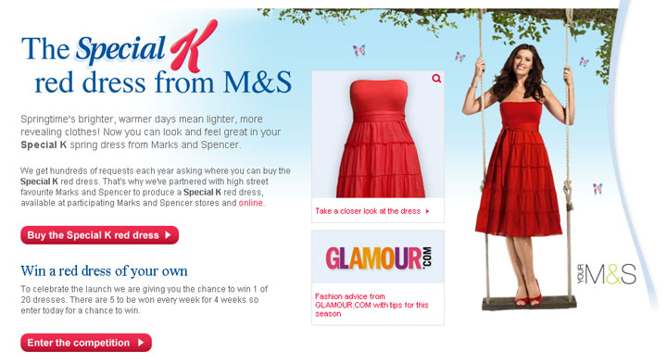
Special K, which is the largest cereal brand in the UK with sales of £120 million, is famous for its iconic advertising featuring the 'Special K girl' dressed in red.
The venture into fashion by Special K, which celebrated its 50th anniversary last year, is a commercial first for the brand which is targeted at shape watching women.
Greg Peterson, managing director, Kellogg's UK Marketing & Sales, explained: "Special K consumers have been asking us for years where they can buy the dresses featured in our advertising and this partnership with M&S has given us the opportunity to finally be able to offer women the chance to do so.
"The marriage between Special K and fashion is a natural fit - linking up with M&S has given both brands a unique commercial opportunity to joins forces to meet the needs of both our consumers."
M&S announced in November last year that it was to roll out plans to stock branded FMCG goods at its stores nationwide - including Kellogg's Special K.
A spokesperson from M&S said: "The M&S red dress is an extremely versatile summer essential which can be dressed up or down and is sure to flatter any figure. The Special K dress has become a fashion icon in its own right so we are proud to be the first retailer to offer this famous dress to customers."
The Special K red dress at M&S is featured on pack and is worn by the Special K girl in the cereal’s latest £3m "Love Your Summer Shape" advertising campaign and will be available at selected stores throughout the UK and online.
About the Kellogg company:
Since William Keith Kellogg filed the papers that officially incorporated the Battle Creek Toasted Corn Flakes Company on 19th Feb 1906, the Kellogg Company has been driven by the philosophy that an improved, balanced diet, starting with a healthy breakfast, leads to improved health.
The Kellogg Company is now the most successful cereal manufacturer in the world and offers nutrition advice and tips as well as a BMI calculator.
For further information and images please contact:
Louise Davies
Official Press Office of Kellogg Marketing and Sales Company (UK) Limited
The Kellogg Building
Talbot Road
Manchester
M16 0PU
0161 869 2942
www.specialk.co.uk
~~~~~

Press release distributed via EPR Network (http://express-press-release.net/submit-press-release.php)

