MyTights Launches Henry Holland's New Collection For Pretty Polly


Released on: April 17, 2010, 12:03 am
Author: MyTights
Industry: Apparel & Fashion
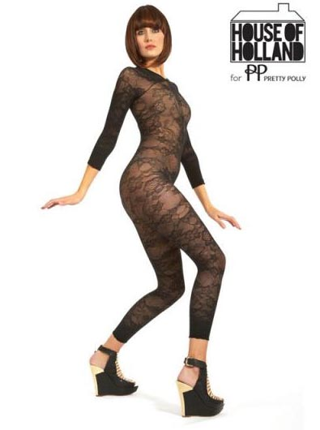
MyTights welcomes five fabulous new hosiery products from one of the most sought after and innovative collections: Henry Holland for Pretty Polly. This enhanced collection from House of Holland consists of a limited edition all over Lace Body Suit, Lace Panel Tights, a selection of coloured Lace Footless Tights, and the celebrity favourite – Contrast House Tights, as well as the return of the Super Suspenders! With quirky designs that stay true to the British Designer’s heritage and starting from as low as £12, these latest additions to the Pretty Polly range are sure to be the most sought after fashion hosiery of the season.
Henry Holland’s limited edition all over Lace Body suit (£35) is a super sexy and fashion forward must have, and is available in classic black. The carefully crafted open toe design allows for more footwear choices and will immediately separate the trend adopters from the trend followers.
Henry Holland continues to aid women in their quest to instantly and simply update their outfits this season with his Lace Panel Tights –featuring an edgy and on trend mix of sheer lace and opaque fabric. Priced at a fantastically affordable £12, these tights are more than worth it and to avoid fuss they are available in one size and one colour: seductive black.
A perfect addition to our wardrobes for the upcoming season is Henry Holland’s Lace Footless Tights (£12). The intricate design is set to make legs look worthy of worship and the choice between vibrant pink, milky pastel purple and promising black means colour and style can be easily added to any ensemble this Spring! It is well worth adding these footless tights to every wardrobe armoury.
Contrast House Tights (£12) featuring the signature House of Holland logo are another addition to the collection. With the iconic logo dotted all over these tights, any woman can walk along proud knowing they have made a real fashion statement with tights from one of the most trendy and famous brands of the moment. Hosiery lover Fearne Cotton has already been spotted donning a pair of these patterned tights, along with model Agyness Dean, and the good news is that these Henry Holland tights are available to purchase at MyTights now. Take your pick of two colours too: one of the season hottest shades “nude” or black for those who want to keep it classic.
MyTights is also proud to welcome back, with warm and open arms, Henry Holland’s Super Suspender Tights (£12) that have almost become one of life’s essentials. At a quick glance they appear to look like suspenders, but look twice and their true identity as tights is revealed. A great way to achieve the sexy look of hold ups without the fuss, no wonder they live up to their hype. With celebrities, like Agyness Deyn and Pixie Geldolf wearing them, it is inevitable they are going to be a huge hit once again.
With the first House of Holland tights collection selling out throughout the United Kingdom, anyone wishing to bag a pair of tights from the latest collection will need to be quick. To view the full collection of House of Holland for Pretty Polly hosiery, please visit http://www.mytights.com/gb/.
Contact Details: MyTights
2 Chesney Street
Battersea
London
SW11 5JT
020 7819 0530
http://www.mytights.com/gb/
suzanne@mytights.com
~~~~~

Press release distributed via EPR Network (http://express-press-release.net/submit-press-release.php)

