Non-Invasive Procedures Help Reduce Frozen Shoulder Syndrome

Released on: April 29, 2010, 2:55 pm
Author: Jane Smith
Industry: Healthcare
London, April 2010: Get ready for a pain-free life if you've been suffering for years from a frozen shoulder. Adhesive capsulitis plagues hundreds of thousands of people every day, but now victims finally have hope. Who knew you could lead a pain-free life with the help of just two books, an exercise band and a DVD? It's time to stop living in the dark ages and embrace the science of the twenty first century, letting the Neil-Asher technique lead the way.
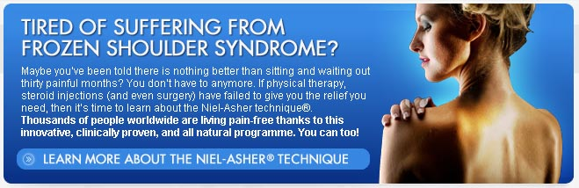
The unique aspect of this technique focuses on the body's ability and capacity to heal itself. It's the most basic way of healing your body and its secret lies in its simple way of thinking. Healing is not dependent on drugs or surgery; this method works by stimulating new pathways in the brain, rapidly reducing injury and spasms, and increasing strength and power. Using a varied set and a specific sequence of manipulations and pressure points of the shoulder joints and soft-tissues, it's a hands-on holistic form of healing. In effect, what it does is 'fool' your brain and therefore your body into healing itself.
Where physical therapy tries to improve the range of motion by forcing the shoulder through the blockage, the Niel-Asher technique is a method of natural sequences of applying pressure to specific points, which eases the stress and pain. When we get shoulder injuries, the brain responds by 'switching off' normal muscular co-ordination. There are a number of problems that arise when this happens, and the chief and most common one is a frozen shoulder. The Niel-Asher technique works by stimulating a sequence of reflexes and sending new messages to the brain.
The frozen shoulder syndrome might start off as a niggling pain that can build up to stiff joints and ultimately partial immobility. Steroids and operations have had little or no effect and this is where the natural and holistic method of Mr Simeon Niel Asher proves to be a winner, guaranteeing at least 80 percent reduction in shoulder joint pain.
What starts off as a minor muscle pull could debilitate into something more painful and agonising. Instead you can let the power of nature heal you, and let your body take charge. Niel-Asher's books and accompanying DVD guide are easy to follow, and have proven to be effective in reduction of pain. Why live in pain when there is a solution that is safe, non-invasive, and proven to relieve your discomfort and suffering? There isn't much you have to do except follow the technique and let trained therapists help you lead a healthier life.
This is a treatment that can last from anywhere between 4 to 13 sessions. There are no invasive procedures and the method is natural and drug free. There are Niel-Asher clinics all across the world that guarantee shoulder pain will a distant memory.
Contact Details: 21 Wilbury Grove
Brighton & Hove
United Kingdom
independentjournalismproject@gmail.com
http://www.frozenshoulder.com/index_a.html
~~~~~

Press release distributed via EPR Network (http://express-press-release.net/submit-press-release.php)

