The Harley Medical Group Challenges Traditional Beauty Solutions


Released on: April 13, 2010, 12:15 am
Author: The Harley Medical Group
Industry: Healthcare
The Harley Medical Group is launching a new advertising campaign designed to highlight the more practical solutions offered by cosmetic and non surgical procedures.
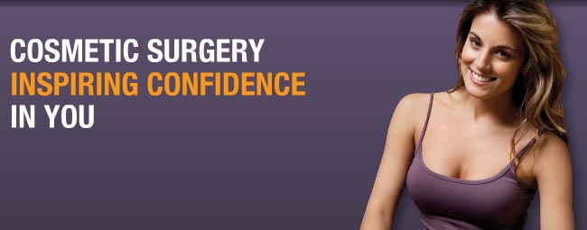
The UK's largest cosmetic surgery company hopes to tap into the day-to-day concerns of the ‘ordinary' person to demonstrate how, contrary to some common perception, cosmetic solutions can give less dramatic and more functional beauty solutions.
The adverts, designed by Medicine Man, include an image of the bottom half of a bikini-clad woman's body with the tag line "Bad hair day…ever considered laser hair removal."
Another highlights how on average a woman will shave her legs 11,500 times - suggesting laser hair removal as a safe, permenant and hassle-free alternative.
Liz Dale, Director, The Harley Medical Group commented, "The adverts are now appearing on the back-end of buses across the UK. We deliberately set out create advertising that will make people do a double-take and demonstrate clearly how cosmetic and non surgical treatments can be an effective solution to unwanted hair or the removal of stubborn fat ."
The series of five adverts cover liposuction, breast surgery, lines and wrinkles treatments and laser hair removal.
Liz Dale added, "We wanted to be more matter-of-fact in our communication style and focus on how cosmetic procedures can be practical, as well as affordable and attainable for most people, by highlighting the solutions in a tangible way. We're launching the advertising now as people begin to think of getting their bodies beach-ready for the summer."
About The Harley Medical Group
The Harley Medical Group is the UK's largest cosmetic surgery provider, performing more procedures and with more clinics than any other cosmetic surgery provider. It has been established for more than 26 years and is one of the most highly-regarded cosmetic surgery groups operating in the UK. It has treated more than 450,000 patients to date including popular procedures such as laser hair removal and breast enlargement.
The Harley Medical Group works tirelessly to maintain the highest standards in the industry for the benefit of all cosmetic surgery and non surgical patients. The Harley Medical Group is currently at the forefront of the campaign to ensure that the government continues to regulate the use of certain laser types used in cosmetic surgery and non surgical treatments so that patients are protected from rogue practitioners.
PR Contact:
Hannah Walsh
Rain UK
2 Greycoat Place
London
SW1P 1SB
020 7222 4345
www.harleymedical.co.uk
~~~~~

Press release distributed via EPR Network (http://express-press-release.net/submit-press-release.php)

