Topshop Launches Its High Summer 2010 Collections


Released on: April 20, 2010, 12:03 am
Author: Topshop
Industry: Retail
Topshop has launched its High Summer 2010 collections, just in time for the sunshine. To accompany the new collections, Topshop customers can access a behind-the-scenes video from the brand’s advertising campaign shoot which shows the newest trends for the summer season. Packed with styling ideas, it is the perfect way to get inspired and choose what to fill your wardrobe with.
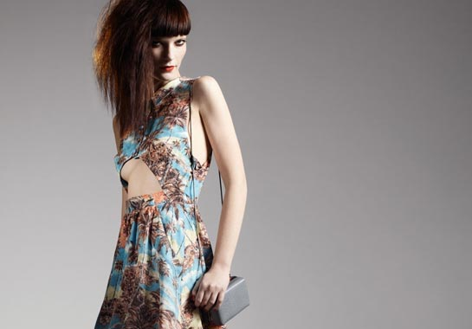
Topshop’s in-house design team have the enviable task of finalising the trends the store will feature each season. They do this by trawling the globe in search of the most exciting new pieces, snapping great street style looks, and being inspired by all the cool places they visit. These ideas are then brainstormed, developed, and crystallised into the current Topshop High Summer collections.
For summer there are a lot of new looks to have fun with. Summer Fete offers a mix of sorbet shades, pretty prints and bleached-out denim, whilst in Festival Army, military-inspired pieces have a grungy edge. In Club Tropicana, body conscious summer dresses and hotpants in bold prints and colours look at home on the beaches of Rio de Janeiro. Finally, jersey maxi dresses, sleeveless denim gilets and towering platforms offer slick city chic in Body Armour. Topshop dresses continue to be key, particularly those featuring pretty sherbet colours and pastel ginghams. Shoes are also a big trend for SS10 with wedges and clogs taking centre stage.
Topshop’s behind-the-scenes video was filmed at its high summer shoot, offering inspiration on how best to style up the seasons’ newest looks. The film shows photographer Josh Olins and stylist Kate Phelan at work, with hair by Shon and make-up by Hannah Murray, consultant on Topshop Make Up, the store’s forthcoming make-up line (due out in May).
Topshop is also getting ready for the new Kate Moss Topshop collection in May.
About Topshop
Topshop was established in 1964 and is part of Arcadia Group Ltd. Sir Philip Green became owner of Arcadia Group Ltd in 2002.
Topshop is continually recognised as being an authority on women's clothing, having won several awards for design reputation and new services, and has a wide range of womens dresses, chunky shoes, maternity clothing, jackets and womens jeans.
Topshop was the first fashion retailer to show on schedule at London Fashion Week in September 2005 and continues to grow its reputation for supporting exciting new talent.
For further media information, photos and comments please contact:
Liz Shuttleworth
Press Officer
Press Office
Arcadia Group Ltd
70 Berners Street
London
W1T 3NL
020 7927 1484
www.topshop.com
~~~~~

Press release distributed via EPR Network (http://express-press-release.net/submit-press-release.php)

