VoAPPs Announces Outbound Voicemail Service

DirectDROP Voicemail Delivers Pre-Recorded Voice Messages - without ringing the phone.



Released on: April 05, 2010, 8:41 pm
Author: DirectDROP
Industry: Telecommunications
ATLANTA —April 5, 2010 — Today VoAPPs announced the availability of DirectDROP Voicemail, a hosted service that drops pre-recorded messages straight into someone's voice mailbox – without ringing the phone.
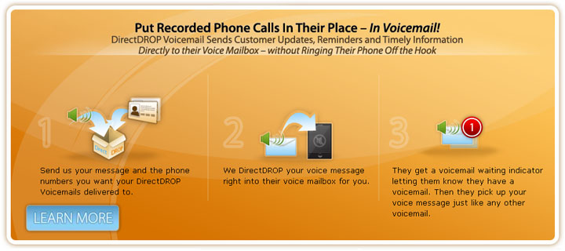
Designed for the commercial outbound messaging market, DirectDROP Voicemail delivers pre-recorded voice messages to scores of recipients at the press of a button. DirectDROP works on any network (mobile or landline) and on any service plan (prepaid, postpaid, or monthly subscriptions). It is compatible with both residential landline telephones and with any mobile handset (feature phones, smartphones, iPhone, etc.). Plus, DirectDROP utilizes voicemail so it offers more reach than other commonly used outbound messaging tools like text and email. In fact, almost all US mobile service plans include voicemail and the penetration of voicemail is nearly 34% for residential phones. That means there are over 300 million voice mailboxes in the US, reaching over 98% of US telephone users over 15 years old.
“The universal nature of DirectDROP makes it perfect for getting a company's message across” says David King, President of VoAPPs. “Whether it's an appointment reminder, a flight update or a political campaign call, now outbound messaging users can avoid the customer tension created by an ill-timed phone call." With DirectDROP Voicemail, companies can send pre-recorded updates, reminders and other timely information directly to their customer's voice mailbox. Since the voice message bypasses the customer and goes straight to voicemail, it doesn't ring their phone or leave a missed call indicator.
With DirectDROP Voicemail, the recipient gets a message waiting indicator and then, when they check their voicemail, the DirectDROP voicemail is there waiting for them. They can listen to it, replay it, save it, delete it and manage the voice message just like any other voicemail – it just didn't ring their phone!
About VoAPPs.
VoAPPs creates innovative, easy to use Voice Applications such as DirectDROP Voicemail.
DirectDROP puts recorded phones calls in their place - in voicemail!
#########
For more information on DirectDROP Voicemail:
info@voapps.com
http://www.DirectDROP.me
~~~~~

Press release distributed via EPR Network (http://express-press-release.net/submit-press-release.php)

