Volusia Manufacturers Association Manufacturing Member, Don Bell Signs, Wins Second Place in 2010 International Sign Contest

Released on: April 21, 2010, 9:08 pm
Author: WebWax.net
Industry: Small Business
Volusia Manufacturers Association (VMA) is the only manufacturing trade association established by manufacturers uniting Volusia and Flagler County Manufacturers and Associates. The Volusia Manufacturers Association was founded in 1980 in Daytona Beach, Florida and currently has over 180 Manufacturing and Associate members in the Daytona Beach area.
Don Bell Signs, a national sign fabricator located in Port Orange, Florida, and a long-standing Volusia Manufacturers Association Manufacturing Member, recently won Second Place in the 2010 International Sign Contest's Sign Systems category for the best exterior signage. Signs of the Times magazine has been a leading source of far-reaching sign-industry news and technical information since 1906. Its online version, SignWeb serves to educate and inspire signage and graphics professionals worldwide through editorials, technology updates, new product reviews, cutting-edge graphics techniques, and more. Its Annual International Sign Contest has such categories as best unique signs, best electronic message centers, best electric building signs, best commercial building signs, best electric freestanding signs, best commercial freestanding signs, best murals/banners/supergraphics, best electric monument signs, best commercial monument signs, best sign systems, and best exhibit graphics.
The award-winning sign was built for client, AMC Theaters, located in Kansas City, Missouri, with the design by Selbert Perkins Design. Don Bell Signs manufactured and installed a 68' x 6' marquee that features an EVIDA 10mm LED motion-graphics board that curves to fit the façade. They also manufactured and installed a 60' x 11' blade sign featuring channel letters illuminated with GE Lumination's red Tetra LED strips and faced with red acrylic.
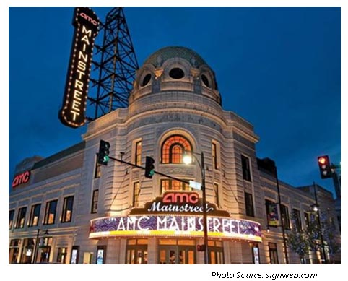
Don Bell Signs' custom signs have won numerous design and manufacturing awards nationwide. Don Bell Signs services widely range from sign design, structural and certified engineering, sign permit and variance acquisition, sign fabrication, project management, sign installation, and routine maintenance services for all types of signage. Don Bell manufactures and installs Pylon Signs, Monument Signs, Channel Letters, LED Signs, LED Scoreboards, LED Video Displays, Time and Temp Displays, Electronic Digital Signage, Stadium Displays, Architectural Signage, Environmental Graphics, Wayfinding, Neon, and Marquees, to name a few.
“Don Bell Signs has been a leading manufacturer in the Daytona Beach area since 1947,” said Jayne Fifer, President and CEO of the Volusia Manufacturers Association.” Fifer also said, “As a manufacturer of custom signs, they are one of the few sign companies that produce all major components of a LED sign within their Daytona Beach manufacturing facility. The Volusia Manufacturers Association congratulates Don Bell Signs on its international achievement.”
The Volusia Manufacturers Association offers information, education, and networking opportunities for members, with over 60 programs annually. For more information about the Volusia Manufacturers Association, please contact Volusia Manufacturers Association or Jayne Fifer at 386.673.0505.
About Volusia Manufacturers Association:
The Volusia Manufacturers Association was founded in 1980 in Volusia County, Florida by manufacturers for manufacturers. Volusia Manufacturers Association provides information, education and networking opportunities to help manufacturers grow and succeed. VMA are made up of companies that range in size from one employee to over 500. If you are interested in joining the Volusia Manufacturers Association, please visithttp://www.vmaonline.com .
Summary : The Volusia Manufacturers Association's Manufacturing Member, Don Bell Signs, wins Second Place in the annual Signs of the Times Sign Contest.
Contact Information:
Jayne Fifer
President/CEO
Volusia Manufacturers Association
jayne.fifer@VMAonline.com
386.673.0505
Fax: 386.673.6663
Cell: 386.212.4003
www.VMAonline.com
~~~~~

Press release distributed via EPR Network (http://express-press-release.net/submit-press-release.php)

